Live at Lincoln Castle

Accessibility Statement

At Live at Lincoln Castle we are committed to providing a welcoming and inclusive environment for all our attendees.
We have a dedicated accessibility team working all year round to assist customers with accessibility requirements.

Please note that our accessible facilities are unable to cater for people with temporary impairments. This is considered to be anything that affects an individual for less than 12 months such as broken bones, healing injuries or pregnant women.

Alternative Formats

If you require easy ready, BSL translated, audio or any further alternative formats please contact us here and our accessibility team can arrange for you.

Accessible Ticketing

How do I purchase an accessible ticket?

We want Live at Lincoln Castle to be an event accessible for all.

To ensure we have the correct level of facilities we ask customers to purchase the correct type of accessible ticket on Ticketmaster.

The following options are available:
- Wheelchair
- Ambulant
- Deaf/Hard of hearing
- Essential Companion

To purchase an accessible ticket please click here

To contact us about purchasing access tickets, or to ask further questions about the process, please email access@ticketmaster.co.uk. or visit help.ticketmaster.co.uk

If you have further questions on the accessible facilities, please visit the events help centre here or email us here - info@depotcardiff.com

Essential companion tickets

There is an option to select a companion ticket when you are purchasing an accessible ticket. Once you have selected a companion ticket, there will be an approval process. For the approval process, you will be contacted to provide supporting documentation for validation of your request.

If you require a companion ticket in the general admission or premium
area. Please contact Ticketmaster’s access team here to request - access@ticketmaster.co.uk.

Accessible Documentation

To ensure fans are receiving the correct accommodations and that Free Essential Companion tickets are going to eligible fans, you'll have three weeks to submit proof of eligibility after requesting accessible tickets. Your order may be cancelled if no supporting document is provided.
Below is a list of documents we may accept when considering allocating a complimentary ticket:
- PIP (Personal Independence Payment)
- DLA
- Letter from a medical professional, including a doctor’s note or a letter from an occupation therapist
- Carer's allowance
- A Nimbus Access Card with the +1 symbol. Visit the Access Card page for more information.
- Confirmation in writing from Social Services that the individual is included on their Deaf Register, or a letter or report from an aural specialist confirming that hearing loss has been recorded at 70 - 95 dBHL or worse
- War Pensions Mobility allowance
- Blind or partially sighted registration certificate (BD8 or CVI certificate)
- A personal letter from the GP, community nurse or social worker
- Benefit award letters
- Copy of a blue badge (we would need to see both sides)

Further information is available here

To contact us about purchasing disability access tickets, or to ask further questions about the process, please email access@ticketmaster.co.uk.

If you have further questions on the accessible facilities, please contact the event organisers here

If your request for a companion ticket is not approved, the access team can advise on the procedure.

What if I need a companion ticket in the general admission or premium area?

If you require a companion ticket in the general admission or premium area. Please purchase one ticket via Ticketmaster and contact Ticketmaster’s access team here to request - access@ticketmaster.co.uk.

They will issue you a companion ticket if you have the correct accessible documentation. You can find out more on accessible documentation here.

Please note – if there is a hospitality package of the premium ticket, there may be a charge for your companion.

What is a Wheelchair ticket?

The ‘Wheelchair’ ticket is for customers who are attending in a wheelchair or mobility scooter. This ticket allows entry onto the accessible viewing platform which is a raised platform with view of the stage.

The accessible viewing platform has a limited capacity and is strictly for accessible customers plus their companions.

Customers who have purchased a wheelchair ticket are also entitled to a companion ticket. They will be contacted to provide accessible documentation for a companion ticket.

The viewing platform have ramped access, charging points and a member of staff is located on each platform to offer any help that may be needed.

What is an Ambulant ticket?

An ambulant ticket is for customers who have an accessibility requirement that require them to have access to a chair/and or quieter area to make their experience more comfortable.
Ambulant ticket holders can access the accessible viewing platform, which is a raised platform with view of the stage where chairs are provided
Customers who have purchased an ambulant ticket are also entitled to a companion ticket. They will be contacted to provide accessible documentation for a companion ticket.

What is a Deaf/Hard of Hearing tickets?

Deaf/Hard of Hearing ticket holders can access the accessible viewing area or the general admission area, with the BSL interpreter positioned near the left side of the stage (customer view).
If you need alternative accessible facilities, such as platform access or accessible toilets, please get in touch with us, and we’ll be happy to look into this and discuss further. [Please note – the platform may be at capacity].
Additionally, Deaf/Hard of Hearing customers are entitled to a complimentary companion ticket. You will be contacted to provide the necessary accessible documentation to confirm eligibility - You can find out more on this here
You can find out further information on the BSL interpreters tab below.

I don’t need a wheelchair or ambulant ticket; I just need to access the accessible facilities – what do I do?

If you do not need a wheelchair, ambulant or hard of hearing ticket but have accessible requirements that would benefit from the use of the accessible facilities, such as the toilets and entrance – please contact our access team here who can explain further.

Arena Accessible Facilities

Accessible Toilets

Accessible toilets are available at all main toilet blocks within the arena.
Additionally, there are accessible toilets within the designated accessible area for accessible ticket holders. These are located inside the building, offering more space and running water compared to standard portable units.
If you need to use the monitored accessible toilets in the accessible area but do not have an accessible ticket, please contact our accessibility team for further assistance here
For VIP ticket holders, a luxury accessible trailer is also available in the VIP area.

Accessible Viewing Platform

The accessible viewing platform is available for customers with a wheelchair accessible ticket.

It is raised platform located with prime view of the stage.

There are accessible toilets located nearby.

This area is for customers who require a wheelchair to make their experience comfortable.

The accessible viewing platform has a limited capacity and is strictly for access customers plus 1 companion only.

There will be charging points for mobility scooters/electric wheelchairs at the viewing platform.

Accessible Viewing Area

The accessible viewing area is a raised space located directly in front of the viewing platform, with seating provided.

It is designated for customers with an ambulant ticket and is intended to accommodate those with specific medical requirements for a more comfortable experience.

Companions are welcome to use the seating in the viewing area.

To purchase a ticket for the accessible viewing area, please select an ambulant ticket.

Terms and Conditions
- The Accessible Viewing Platform is designated for Wheelchair ticket holders and The Viewing Area is for Ambulant ticket holders.
- Only customers with valid Wheelchair or Ambulant Accessible tickets, and their Essential Companion, may access the Accessible Viewing Platform or Viewing Area, as applicable to their ticket type.
- Access will be controlled via a wristband system.
- The Accessible Viewing Platform and Viewing Area include ramped access, wheelchair-accessible toilets nearby and Charging Points.
- The Accessible Viewing Platform and Viewing Area are not covered; customers should dress appropriately for all weather conditions.
- Smoking, including e-cigarettes and vapes, is not permitted.
- Staff and security reserve the right to ask any customer to leave the Platform and Area if behaving inappropriately.

Accessible Bar Lanes

Lowered countered bars/accessible lanes are available for all accessible ticket holders and will be situated around the festival site at most bars

If a lowered bar counter is not possible, and when appropriate, a member of staff will be able to come around from the bar to take your order and assist you.
The Accessibility pack, available closer to the event, will indicate the locations of lowered bar counters.
Site Description

Graphical Map

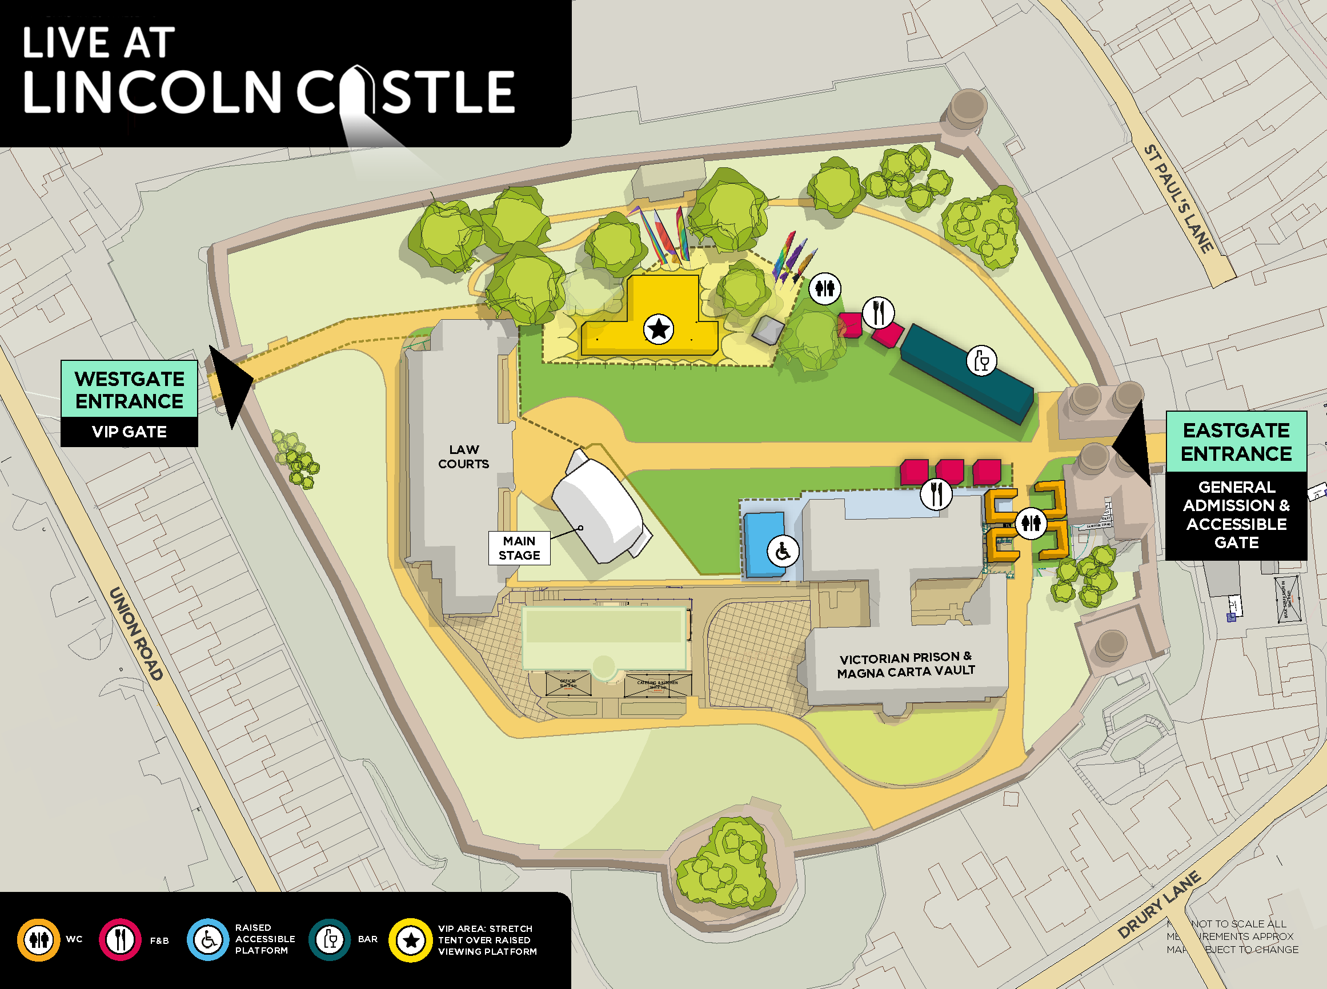
Weather
This is an outdoor concert, and we advise attendees to dress appropriately and bring suitable clothing for changing weather conditions. As temperatures may drop in the evening, we recommend bringing a jacket or additional layers for warmth and comfort.
Ground Conditions
Live at Lincoln Castle takes place at Lincoln castle, a greenfield site therefore is relatively flat but does have uneven terrain in parts.
The arena features grass, temporary trackway and there is a hard standing path running the length of the site.
The entrance has cobbled pavement due to it being within the castle grounds. You can see a image of this here for further reference.
You can view Lincoln Castle on Google Maps here: Lincoln Castle
Please note: The terrain may be uneven in parts, and depending on weather conditions, the ground may be muddy or dusty.

Accessible entrance

The Accessible Lane is via East Gate.

The entrance has cobbled pavement due to it being within the castle grounds. You can see an image of this here for further reference.

Once inside the arena, there is a hard standing path and temporary flooring that leads you to the accessible area.

Upon arrival, you will be required to present your digital ticket, undergo a security bag check, receive an accessibility wristband, and be directed to the accessible viewing platform. Staff will be on hand to assist, and clear signage will be provided.

You can find out more on digital tickets here

Deaf/Hard of Hearing Facilities

BSL (British Sign Language)

We are pleased to offer a British Sign Language (BSL) interpreter for all Live at Lincoln Castle 2025 concerts.
If you require a BSL interpreter, please purchase a Deaf/Hard of Hearing ticket via Ticketmaster.
Deaf/Hard of Hearing ticket holders can access the general admission area, with the BSL interpreter positioned near the left side of the stage (customer view).
If you need alternative accessible facilities, such as platform access or accessible toilets, please get in touch with us, and we’ll be happy to look into this and discuss further. [Please note – the platform may be at capacity].
Additionally, Deaf/Hard of Hearing customers are entitled to a complimentary companion ticket. You will be contacted to provide the necessary accessible documentation to confirm eligibility - You can find out more on this here
The BSL Interpreting Team for Live at Lincoln Castle are listed below:
- Charlotte Anderson
- Stephanie Mann
[Please note - Subject to change].
If you have any questions, please contact us here
Hearing Loops

There are portable hearing loops available at the box office and main bar (please refer to the map above for exact locations).

Hearing aids need to be switched to the 'T' setting in order to convert the magnetic signal from the loop back into sound. (Please look for the Hearing Loop sign to locate the correct area to be in the frequency radius).

Visually Impaired Facilities

Assistance dogs

Assistant Dogs are permitted on site. If you are bringing a registered assistant dog, please do let us know in the accessible requirements form that is emailed to you by Ticket master after purchasing accessible tickets. Alternatively, please contact us here
Large Print Menus

These are available at all bars. If you require large print menus for traders and merchandise please contact us here.

Sensory Requirements
Strobe Lighting and Special Effects
Smoke machines, strobe lights, fireworks and other effects may be in use at this event. Anyone affected by these should bear this in mind.
If you require further information for a specific performance please contact us here.
Sensory Packs
Sensory packs are available from the accessible area to borrow free of charge.
Each pack contains a fidget toy, ear plugs, sunglasses, and a sensory distraction.
Backpacks are available on a first-come, first-served basis.
Feel free to bring your own sensory supports if you prefer to have them with you.
Please return the backpacks after the show. All items are sterilized between uses, but sterilizing wipes are included in the bag should you wish to clean them yourself

Accessibility Team, Stewards and Security
Accessible Events specialise in accessibility for deaf, disabled and/or neurodivergent customers at large scale events. They will oversee the accessible area and be available to assist with any queries you may have on the night.
All security staff and stewards stationed at accessibility points will be fully briefed on procedures to ensure they can provide appropriate support and information to accessibility customers

VIP Accessible Facilities

Raised deck viewing area
The raised deck has ramp access and is accessible for wheelchairs and mobility scooters.
There is club style furniture set up on the decked viewing platform.
Companions
If you require a companion ticket in the VIP area. Please purchase one ticket via Ticketmaster and contact Ticketmaster’s access team here to request - access@ticketmaster.co.uk.
They will issue you a companion ticket if you have the correct accessible documentation. You can find out more on accessible documentation here.
Ground Conditions
The ground conditions are the same as the festival arena. The site is green field therefore is relatively flat but does have uneven terrain in parts. The ground may be muddy or dusty dependant on the weather conditions.
Lowered Bar
There will be a lowered counter, accessible lane, and signage available at the VIP bar.
Large Print
Large print menus are available at the VIP bar.
Luxury Accessible Toilet
There is a luxury accessible trailer available in the VIP area for VIP ticket holders.
BSL interpreter
If you are a VIP ticket holder and require access to the BSL interpreter, please do contact our team here and they can look into your request and discuss further.

Policies

Food and Drink

There will be various food options available at the festival.
If you need to bring your own food or non-alcoholic drinks due to a medical condition or your access requirements, please request this by contacting us here

Bag Policy

Bags larger than an A4 piece of paper are not permitted. If you require a larger bag due to medical reasons or access requirements, please request this by contacting us here

Medication

Medication in its original packaging, with the prescription label clearly visible, or that is easily recognisable, is allowed without an approval letter.

If the medication is not easily recognisable, please contact us here and we can issue you an approval letter to bring with you on the day of the shows.

Ensure you bring only the necessary amount for the duration of the event, and keep it safe with you at all times.

Medication may be subject to screening at entry points, so please be prepared to provide any necessary documentation, such as a doctor's note, prescription, or the approval letter (printed or digital).

Temporary Impairments/Pregnancy

Please note that Live at Lincoln Castle accessible facilities cannot cater for people with temporary impairments such as broken bones, healing injuries and those who are pregnant. If you do have a temporary impairment or pregnant, please be aware that there will be a lot of walking to get around the festival and not many places to sit.

Customers concerned with any of these points can contact the accessibility team here.

Accessible Travel
Car park

Lincoln Castle is well signposted on brown signs on all major routes into the city.
No accessible parking onsite but the Westgate 1 East Car Park (LN1 3BG) and The Lawn Car Park both have blue badge spaces and are close to the venue.
You can find out more on disabled parking spaces here

Pick up and Drop off
Minster Yard will be the Pick-up and Drop off location. You can access this via Pottergate from the South or Priory Gate from the North.
This is 0.2 miles, 350m and approx. 5–10-minute walk to the entrance.
The route is a mixture of hard standing and cobbles but is relatively flat.

Public transport

It is important for visitors with accessibility needs to know that Lincoln's Steep Hill is not accessible. It is a steep, cobbled street which is unsuitable for wheelchair users or for those with mobility needs.

Lincoln has accessible bus services that can aid you in travelling around the city centre, and up to the Cathedral Quarter. You can find out more on accessibility on buses here

Bus Station

Lincoln has accessible bus services that can aid you in travelling around the city centre, and up to the Cathedral Quarter. You can find out more on accessibility on buses here

Train
Lincoln Central train station is located in the city centre.
From the station it is a 10-minute drive or 20-minute walk.
0.7 miles and 500meters to Lincoln Castle.
There is a taxi rank outside the station.
You can find out about accessibility on Lincoln trains here

Taxi

Mark’s Passenger Services is a local private hire company with wheelchair accessible vehicles. For more information visit the Marks Passenger Services website or call 01522 793816.
Handsome Cabs also offer wheelchair accessible taxis in Lincoln city centre. 24 hour pre-booking is essential. To book, call 01522 545352.

Contact us

If you have any additional requests please email us here to request and our accessibility team will be back in touch.

For access ticketing queries please visit help.ticketmaster.co.uk or contact Ticketmaster access team here - access@ticketmaster.co.uk.

For other access enquires please visit the events help centre here or contact the event organisers here

If you require a call back, please do leave your phone number with a message in the box below and a member of the team will call you back.

