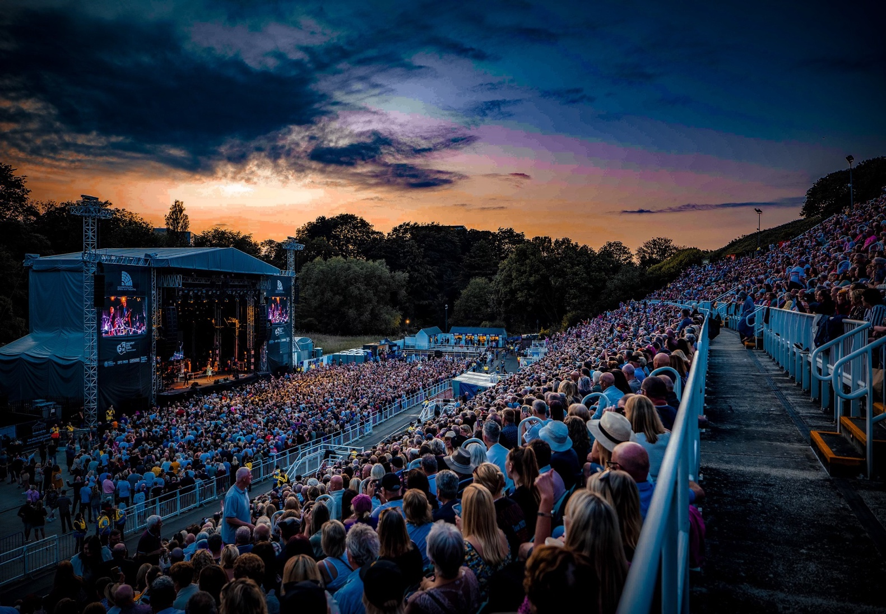

Accessibility Pack

EVENT | TK Maxx Presents Scarborough Open Air Theatre
VENUE | Scarborough Open Air Theatre  Burniston Rd, Scarborough YO12 6PF

INTRODUCTION

We are excited to welcome you to TK Maxx Presents Scarborough Open Air Theatre 2025!

This accessibility pack is designed to ensure that everyone can fully enjoy and participate at our festival.

You will find comprehensive information about the festival, including details on arrival information, travel options, graphical map and distances and accessible facilities. We are committed to providing an exceptional experience for all attendees.

If you require the accessibility pack in an alternative format, please do contact us here and a member of the accessibility team can arrange for you.

CONCERT INFORMATION

CONCERT DATES

Wednesday 11th June | The Corrs + Natalie Imbruglia
Friday 13th June | Gary Barlow + Beverley Knight
Saturday 14th June | Shed Seven / Jake Bugg / Cast
Friday 20th June | Pendulum + Normandie
Saturday 21st June | Basement Jaxx
Friday 27th June | Snow Patrol + Freya Ridings
Saturday 28th June | Human League +T/ Twins+Blancmange
Saturday 5th July | The Script + Tom Walker
Sunday 6th July | UB40/Bitty Maclean
Thursday 10th July | Blossoms + Inhaler + Apollo Junction
Friday 11th July | Rag n BM + Elles Bailey + Kerr Mercer
Saturday 12th July | McFly/Twin Atlantic/Devon
Saturday 19th July | Craig David TS5
Wednesday 23rd July | Judas Priest + Phil Campbell & The Bastard Sons
Saturday 26th July | Texas / Rianne Downey
Saturday 2nd August | Faithless / Orbital
Wednesday 13th August | Smashing Pumpkins + White Lies + Rocket
Sunday 24th August | Will Smith

CONCERT OPENING TIMES

General Admission and Accessible gates will open at 6pm.

Show times are always subject to change; however, we expect entertainment to start at 7pm and finish at 10:30pm.

We would suggest arriving early to soak up the atmosphere.

VENUE DESCRIPTION

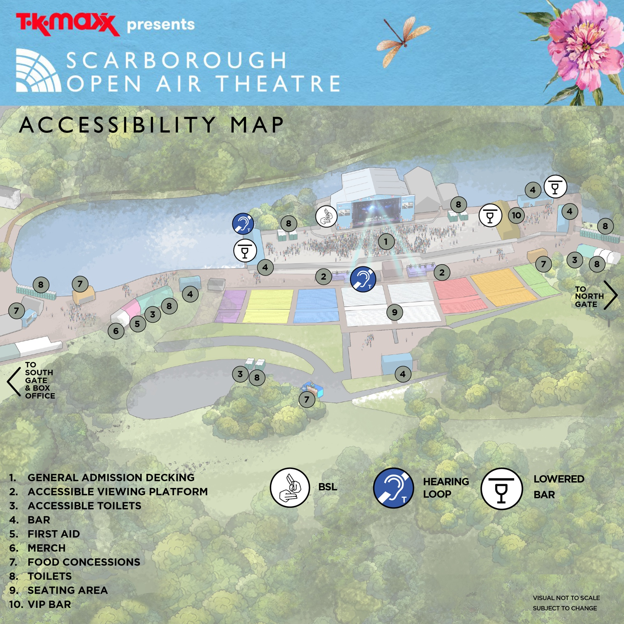
ACCESSIBILITY MAP

DISTANCES
Box office to Entrance: 65m Approx
Entrance Lanes to Accessible Viewing Platform: 215m Approx
Accessible Viewing Platform to the nearest bar: 45m Approx
If you require any further details on the venue, please contact our accessibility team here who are happy to assist.

WEATHER

This is an outdoor concert, and we advise attendees to dress appropriately and bring suitable clothing for changing weather conditions. As temperatures may drop in the evening, we recommend bringing a jacket or additional layers for warmth and comfort.

GROUND CONDITIONS
TK Maxx presents Scarborough Open Air Theatre takes place on hard standing pavement. The building has step free access and is wheelchair accessible throughout.

The path from the entrance to the viewing platform mostly flat, though it does include a slight incline.

You can view Scarborough Open Air Theatre on Google Maps here: Scarborough Open Air Theatre

ARRIVAL INFORMATION

The Accessible Lane is via the main entrance at South Gate (just past the box office).

Upon arrival, you will be required to present your digital ticket, undergo a security bag check and be directed to the accessible viewing platform (if applicable). Staff will be on hand to assist, and clear signage will be provided.

BOX OFFICE

The box office is located near the main entrance to the Open Air Theatre, opposite Northstead Lower Car Park.

Opening Hours – Open Daily

11am – 5pm 1st May – 31st August
10am – 4pm 1st September – 30th April
Closed Wednesdays (except when a concert is scheduled)
Concert days 9am to concert ending
On general sale days the box office will be open for the time tickets go on sale.

WHAT 3 WORDS – KEY ACCESS POINTS

We recommend using the free navigation app www.what3words.com to get around the festival.

What is what3words?
“What3words divided the world into 3 metre squares and gave each square a unique combination of three words. It’s the easiest way to find and share exact locations"

LOCATION (approx) | WHAT 3 WORDS CODE
Pick up and Drop off Point | lively.famous.hang
Box Office | grabs.chair.years
Entrance | small.parent.cubs

TRAVEL INFORMATION

CAR PARK

There is currently no car parking available on site.

If you are an accessible customer and require a car parking space, we would recommend parking in the Northstead Lower Car Park. You can find out more on the car park by clicking here. This is approx 50 meters to the entrance to the venue.

If the Northstead Lower Car Park is full, we recommend parking on Royal Albert Drive. The path from this car park to the theatre is flat which may be more suited to those in a wheelchair. It is approximately 10-15-minute walk (0.7 miles) to the Open Air Theatre from Royal Albert Drive.

The car parking spaces are on a first come, first served basis, therefore it is recommended that you arrive early to ensure a parking space which is suitable for your requirements.

PICK UP AND DROP OFF

There are places to pick up and drop of located at Peasholm Gap which is just around the corner from Scarborough Open Air Theatre. This is approximately a 5-minute walk (approx 400meters)

BUS

All of East Yorkshire buses are low-floor, easy access buses, which are suitable for wheelchairs to travel on. They have ramps at the entrance which mean wheelchairs can easily get on board.

You can find out about accessibility on buses here

TRAIN

Scarborough Train Station is located 1.2 miles (5-minute drive and approx. 30-minute walk) to the venue. Scarborough Station has step free access to all its platforms.
You can find out about accessibility on our trains here

TAXI

Nippys Taxi : Nippy Taxis operate a fleet of wheelchair access and tail lift vehicles. All drivers have completed an appropriate wheelchair safety course.
Number: 01723 377377

FACILITIES

 | Accessible Toilets  Accessible toilets are easily accessible and are located at each end of the venue and close to the platforms.  You can view the location via the venue graphical map on the site description tab below.
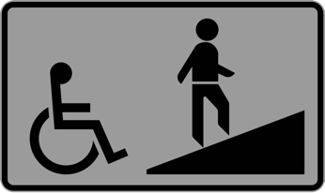 | Accessible viewing platform  There are two wheelchair viewing platforms at the OpenAir Theatre, please refer to the map above. The wheelchair platform is a raised platform located with prime view of the stage.  The wheelchair viewing platforms has a limited capacity and is strictly for access customers plus 1 essential companion.  A member of staff is located on each platform to offer any help that may be needed.
 | Hearing Loops  Hearing loops are available on the left viewing platform (nearest to the entrance) and portable loops can be found at the box office and main bar (please refer to the map above for exact locations).  Hearing aids need to be switched to the 'T' setting in order to convert the magnetic signal from the loop back into sound. (Please look for the Hearing Loop sign to locate the correct area to be in the frequency radius).
 | BSL Interpreters  We will be providing a BSL interpreter for all TK Maxx presents Scarborough Open Air Theatre 2024 concerts.  The shows will be interpreted by Andy Hesselwood [subject to change].  The BSL location will be located near to the left side of the stage (customer view).  Please purchase a Deaf/Hard of Hearing and companion if required and for seated shows, you will be placed within sight of the BSL Interpreter. For standing shows, we recommend locating yourself to the left side of the stage.
 | Medication  Medication in its original packaging, with the prescription label clearly visible, or that is easily recognisable, is allowed without an approval letter. If the medication is not easily recognisable, please contact us here and we can issue you an approval letter to bring with you on the day of the festival.  Ensure you bring only the necessary amount for the duration of the event, and keep it safe with you at all times.  Medication may be subject to screening at entry points, so please be prepared to provide any necessary documentation, such as a doctor's note, prescription, or the approval letter (printed or digital).
   | Accessible Bar Lanes  Lowered bar counters, accessible lanes, and large print menus will be available at most bars throughout the festival site for all accessible ticket holders.  If a lowered bar counter is not possible, and when appropriate, a member of staff will be able to come around from the bar to take your order and assist you.
 | First Aid and Welfare  There are medical and welfare facilities available within the Open Air Theatre. This is located just past the entrance on the right-hand side before you get to your seats. Please ask a member of security to direct you to the facilities if required.
   | Security and Stewards  All security and stewards based at accessibility points will be briefed fully on procedures in order to provide adequate support and information for accessibility customers.  Assistance Dogs  Assistant Dogs are permitted on site.  Please email the accessibility team here if you are bringing a registered assistance dog so we can make sure your seats are suitable.

TERMS AND CONDITIONS FOR ACCESSIBLE VIEWING PLATFORM.

- The Accessible Viewing Platform is designated for Wheelchair and Ambulant ticket holders.
- Only Wheelchair or Ambulant ticket holders and their Essential Companion may access the Accessible Viewing Platform.
- The Accessible Viewing Platform includes ramped access.
- The Accessible Viewing Platform are not covered; customers should dress appropriately for all weather conditions.
- Smoking, including e-cigarettes and vapes, is not permitted.
- Staff and security reserve the right to ask any customer to leave the Platform if behaving inappropriately.

CONTACT DETAILS

You can find further accessibility and event information by clicking here

For accessibility enquires please visit the events help centre here or contact the event organisers here

If you require a call back, please do leave your phone number with a message on our form and a member of the team will call you back.

