|  |  |
| --- | --- |
| TK Maxx Presents Southampton Summer Sessions 2025  Accessibility Pack | |
| EVENT | TK Maxx Presents Southampton Summer Sessions |
| VENUE | Guildhall Square, Above Bar St, Southampton SO14 7DU |

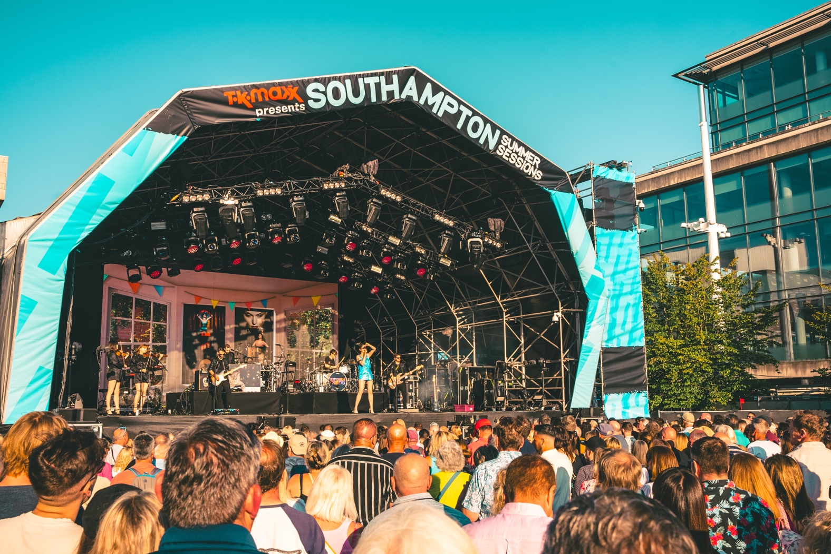

## INTRODUCTION

We are excited to welcome you to TK Maxx Presents Southampton Summer Sessions 2025!

**This Accessibility Pack has been designed to ensure that everyone can fully enjoy and participate in our shows.**

Inside, you’ll find detailed information about the venue, including travel options, arrival guidance, a venue description, a site map with distances, and accessible facilities.

[If you require the access pack in an alternative format, please do contact us here](https://cuffeandtaylorhelp.zendesk.com/hc/en-gb/requests/new) and a member of the access team can arrange for you.

## FESTIVAL INFORMATION

## FESTIVAL DATES

|  |  |
| --- | --- |
| Friday 13th June | Rag n Bone Man, Elles Bailey, Kerr Mercer |
| Saturday 14th June | The Stranglers, Buzzcocks |
| Sunday 15th June | UB40 Featuring Ali Campbell, Bitty McLean, Reggae Roast ft. Mr Williamz |
| Saturday 21st June | Craig David presents TS5, Patrick Nazemi |
| Sunday 22nd June | McFly, Twin Atlantic, Devon |
| Thursday 26th June | Human League, T/ Twins+Blancmange |
| Friday 27th June | Ocean Colour Scene, Cast, Echobelly |
| Saturday 28th June | Train + Matt Hansen |
| Sunday 29th June | Simple Minds / China Crisis |

## FESTIVAL OPENING HOURS

General Admission, The Garden and Accessible gates will open at 6pm. Entertainment Is due to finish at around 10:30pm. We would suggest arriving early to soak up the atmosphere.

## FESTIVAL MAP

## VENUE DESCRIPTION

**DISTANCES**

Entrance to accessible viewing platform - Approx 95m

Accessible platform to toilets - By the platform

Accessible platform to nearest bar - Approx 100m

Box office to entrance - Approx 75m

## WEATHER

This is an outdoor concert, and we advise attendees to dress appropriately and bring suitable clothing for changing weather conditions. As temperatures may drop in the evening, we recommend bringing a jacket or additional layers for warmth and comfort.

## GROUND CONDITIONS

TK Maxx presents Southampton Summer Sessions is on hard flooring and pavement. This is relatively flat however there may be some uneven surfaces and kerbs so please take care when moving around the site.

You can view Southampton Summer Sessions on Google Maps here: [Southampton Guildhall](https://maps.app.goo.gl/7Sbd3zEosnbmRiue7)

## ARRIVAL INFORMATION

You can enter via the main entrance which you can see via the map above.

There will be an accessible lane located here.

Upon arrival, you will be required to present your digital ticket, undergo a security bag check, receive an accessibility wristband, and be directed to the accessible viewing platform. Staff will be on hand to assist, and clear signage will be provided.

## BOX OFFICE

The Box Office is located at Southampton City Art Gallery, Commercial Road, Southampton, SO14 7LP.

What3words: supper.pack.indeed

The Box Office is open from 15:00 to 20:30 during show days

## TRAVEL INFORMATION

## PARKING

There is no car parking on site.

Here is a link to the interactive parking map for council on street and car parks, Including disabled bays.

[Find parking (southampton.gov.uk).](http://southampton.gov.uk/)

## TRAIN STATION

Southampton Railway Station is approximately a 7-minute taxi drive and a 11-minute walk (04. Miles) away from the venue.

[You can find out about accessibility on the trains here](https://www.southwesternrailway.com/travelling-with-us/assisted-travel)

## BUS

Southampton Coach Station Is approximately a 8 minute (0.3 miles) walk away from the venue. To help plan your travel by rail or bus please see the link below.

[Find out more on the bus/coach station here](https://myjourneysouthampton.com/)

## TAXI

Daves Taxi have wheelchair accessible taxis in Southampton.

[You can find out more here](https://www.davestaxis.co.uk/)

[07825 284926](tel:%2007825284926)

[Transmobility](https://transmobility.co.uk/) is the top company for wheelchair taxis in Southampton, and we are dedicated to providing complete wheelchair accessibility services.

[You can find out more here](https://transmobility.co.uk/wheelchair-taxis-southampton/)

[02380 444 555](tel:02380444555)

## WHAT 3 WORDS – KEY ACCESS POINTS

We recommend using the free navigation app[www.what3words.com](http://www.what3words.com/) to get around the festival.

What is what3words?

“What3words divided the world into 3 metre squares and gave each square a unique combination of three words. It’s the easiest way to find and share exact locations"

|  |  |
| --- | --- |
| LOCATION (approx) | WHAT 3 WORDS CODE |
| Box Office | Supper.pack.indeed |
| Accessible Entrance | forms.flash.mile |
| Accessible Viewing Platform | Dime.noble.treat |

|  |  |
| --- | --- |
| **ACCESSIBILE FACILITIES** A wheelchair symbol | Accessible Toilets Accessible toilets are located throughout the site and can be viewed on the map above. Each set of toilet blocks has an accessible toilet.  There are also accessible toilets available in the accessible area and within the Guildhall. |
| A symbol of someone walking up a ramp and a wheelchair | Accessible viewing platform The accessible viewing platform is available for customers with a Wheelchair or Ambulant ticket, plus their companion. It is raised platform located with prime view of the stage.  Please refer to the map above for the location. |
| A wheelchair with battery and power symbol | Charging Facilities If you require access to wheelchair charging facilities, please speak to a member of the accessibility team for assistance. |
| A white sign with a ear inside - hearing loop symbol | Hearing Loops There are portable hearing loops available at the box office and main bar. Hearing aids need to be switched to the 'T' setting in order to convert the magnetic signal from the loop back into sound. (Please look for the Hearing Loop sign to locate the correct area to be in the frequency radius). |
| A black and white sign with two fingers BSL symbol | BSL Interpreters We are pleased to offer a British Sign Language (BSL) interpreter for all TK Maxx Presents Southampton Summer Session 2025 concerts provided by [Complete Communication](https://ddec1-0-en-ctp.trendmicro.com/wis/clicktime/v1/query?url=https%3a%2f%2fcompletecommunicationltd.com&umid=4da7eede-2e18-4a01-8eed-956b96e4cd96&rct=1740413921&auth=5b7e7c02cd9104287ce172cefa2dc966641ad294-cc01f936db853d7f18a04903917237254ab2d22f).  Deaf/Hard of Hearing ticket holders can access the general admission area, with the BSL interpreter positioned on the left side of the stage(customer view).  If you need alternative accessible facilities, such as platform access or accessible toilets, please get in touch with us, and we’ll be happy to look into this and discuss further. [Please note – the platform may be at capacity].  The BSL Interpreting Team are listed below:  Chloe Matthews  Julie Humphries  Sarah Webb  Sarah Ankers  Daryl McMullan  [Please note - Subject to change].  If you have any questions, please contact us here |
| A black and white image of a pill | Medication Medication in its original packaging, with the prescription label clearly visible, or that is easily recognisable, is allowed without an approval letter. If the medication is not easily recognisable, please contact us here and we can issue you an approval letter to bring with you on the day of the festival.  Ensure you bring only the necessary amount for the duration of the event, and keep it safe with you at all times.  Medication may be subject to screening at entry points, so please be prepared to provide any necessary documentation, such as a doctor's note, prescription, or the approval letter (printed or digital). |
| A burger outlineA black coffee cup with steam coming out and a burger outline | Bars and Traders Lowered bar counters, accessible lanes, and large print menus will be available at most bars throughout the festival site for all accessible ticket holders.  If a lowered bar counter is not possible, and when appropriate, a member of staff will be able to come around from the bar to take your order and assist you. |
| A black fidget spinner | Sensory Packs Sensory packs are available from the accessible area to borrow free of charge.  Each pack contains a fidget toy, ear plugs, sunglasses, and a sensory distraction.    Backpacks are available on a first-come, first-served basis.    Feel free to bring your own sensory supports if you prefer to have them with you.    Please return the backpacks after the show. All items are sterilised between uses, but sterilising wipes are included in the bag should you wish to clean them yourself |
| Round circle, with black square inside. Medical symbol | First Aid and Welfare There are medical and welfare facilities available within the arena. Please ask a member of security to direct you to the facilities if required. |
| A black background with a black square | Accessibility Manager, Security and Stewards. **An Accessibility Manager will be on-site, trained in supporting disabled, deaf, and/or neurodivergent customers. They will oversee the accessible area and be available to assist with any queries you may have on the night.**  **All security staff and stewards stationed at accessibility points will be fully briefed on procedures to ensure they can provide appropriate support and information to accessibility customers.** A black silhouette of a dog  Assistance Dogs Assistance dogs are permitted on site. [Please get in touch here if you are bringing a registered assistance dog](https://cuffeandtaylorhelp.zendesk.com/hc/en-gb/requests/new?ticket_form_id=7523357539741). |

## TERMS AND CONDITIONS FOR ACCESSIBLE VIEWING PLATFORM

* The Accessible Viewing Platform is designated for Wheelchair and Ambulant ticket holders.
* Only Wheelchair or Ambulant ticket holders and their Essential Companion may access the Accessible Viewing Platform.
* Access will be controlled via a wristband system.
* The Accessible Viewing Platform includes ramped access, wheelchair-accessible toilets nearby.
* The Accessible Viewing Platform are not covered; customers should dress appropriately for all weather conditions.
* Smoking, including e-cigarettes and vapes, is not permitted.
* Staff and security reserve the right to ask any customer to leave the Platform if behaving inappropriately.

## CONTACT DETAILS

[You can find further accessibility and event information by clicking here](https://cuffeandtaylorhelp.zendesk.com/hc/en-gb/articles/16105036496925-Frequently-Asked-Questions-TK-Maxx-Presents-Southampton-Summer-Sessions)

For accessibility enquires please visit the [events help centre here](https://cuffeandtaylorhelp.zendesk.com/hc/en-gb) or  [contact the event organisers  here](https://cuffeandtaylorhelp.zendesk.com/hc/en-gb/requests/new)

If you require a call back, please do leave your phone number with a message on our form and a member of the team will call you back.