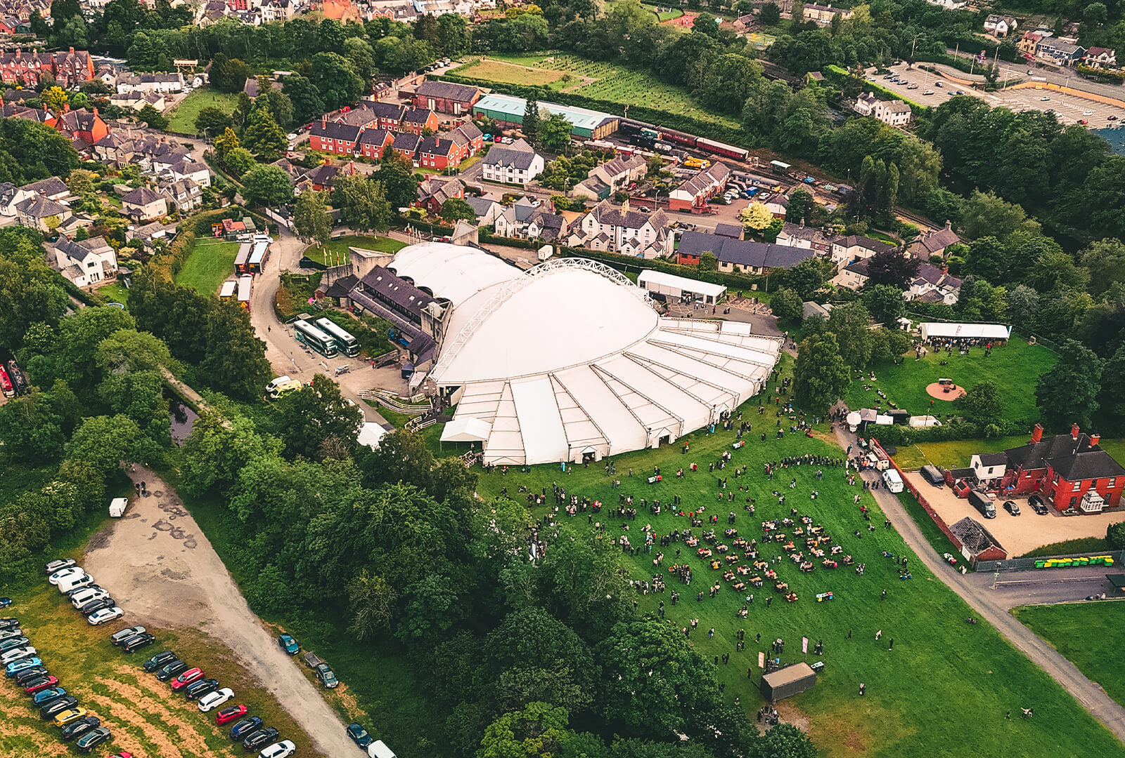

TK Maxx Presents Live at Llangollen Pavillion Accessibility Pack

|  |  |
| --- | --- |
| EVENT | TK Maxx Presents Live at Llangollen Pavillion |
| VENUE | Llangollen Pavilion, Abbey Road, Llangollen, Denbighshire, LL20 8SW |

## INTRODUCTION

We are excited to welcome you to TK Maxx Presents Live at Llangollen Pavilion 2025!

**This Accessibility Pack has been designed to ensure that everyone can fully enjoy and participate in our shows.**

Inside, you’ll find detailed information about the venue, including travel options, arrival guidance, a venue description, a site map with distances, and accessible facilities.

[If you require the accessibility pack in an alternative format, please do contact us here](https://cuffeandtaylorhelp.zendesk.com/hc/en-gb/requests/new) and a member of the access team can arrange for you.

## FESTIVAL INFORMATION

## FESTIVAL DATES

|  |  |
| --- | --- |
| Thursday 26th June | Texas, Rianne Downey |
| Friday 27th June | Rag n Bone Man, Kerr Mercer, Elles Bailey |
| Saturday 28th June | UB40 Featuring Ali Campbell, Reggae Roast ft Mr Williamz, Bitty Mclean |
| Sunday 29th June | James, The K’s, Tom A Smith |
| Thursday 3rd July | The Script, Tom Walker |
| Friday 4th July | Olly Murs, Lemar, Absnt Mind |
| Saturday 5th July | The Human League, Altered Images, The Christians |

## A map of a park AI-generated content may be incorrect.FESTIVAL MAP

## VENUE DESCRIPTION

## DISTANCES

**Penddol-End entrance**

It is approx. 100m from the accessible car park.

It is approx. 60m from the pick-up and drop off zone.

It is approx. 200m from the Penddol-End entrance to the pavilion.

**Town-End Pedestrian entrance**

It is appox 50m from entrance to the pavilion.

It is approx. 15m from the pavilion entrance to the accessible platform or seating areas.

## WEATHER

The accessible seating takes place in the auditorium – however the bars, food and toilets situated outside the indoor area. We advise attendees to dress appropriately and bring suitable clothing and footwear for changing weather conditions. As temperatures may drop in the evening, we recommend bringing a jacket or additional layers for warmth and comfort.

## GROUND CONDITIONS

There is a tarmac path all around the site. Please be aware that there are some uneven parts which have more bumps and some gravel flooring. The middle of the venue is a greenfield which is relatively flat but can become muddy depending on weather conditions. Any customers with accessible platform tickets can access the venue without going onto the greenfield.

## ARRIVAL INFORMATION

You can enter via either entrance (Penddol-End or Town-End entrance). However, Penddol-End entrance is nearest to the pick-up and drop off zone and the accessible car park. The Town-End is the nearest pedestrian entrance to the town centre.

Upon arrival, you will be required to present your digital ticket, undergo a security bag check, receive an accessibility wristband, and be directed to the accessible viewing platform. Staff will be on hand to assist, and clear signage will be provided.

## TRAVEL INFORMATION

## PARKING

Accessible parking is strictly reserved for Blue Badge holders. A limited number of spaces are available and cannot be guaranteed or reserved.

**Pre-booked accessible parking:** £10

**On-the-day (non-pre-booked) parking:** £15

Accessible parking is located via the Abbey Road entrance, which also serves as a designated drop-off point. After drop-off, vehicles must be moved to the main event car park.

To pre book accessible parking for concerts see below

Texas: <https://www.ticketmaster.co.uk/event/1F00613BE15B4660>

Rag n Bone man accessible parking is sold out.

UB40: <https://www.ticketmaster.co.uk/event/1F00615ED80A477B>

James: <https://www.ticketmaster.co.uk/event/1F006167EE9D3256>

The Script: <https://www.ticketmaster.co.uk/event/1F006134C3E92208>

Olly Murs: <https://www.ticketmaster.co.uk/event/1F006139F15241DD>

Human League : <https://www.ticketmaster.co.uk/event/1F00613BB7FE2BF9>

## PICK UP AND DROP OFF

There is a pickup and drop off point available at Abbey Road which is next to the main entrance at Penddol-End gate.

## ****TRAINS****

Transport for Wales operates two lines that stop at Ruabon and Chirk. Both are 15 minutes by car to Llangollen. Ruabon is connectable by bus. The North Wales Coast Line between Holyhead and Birmingham New Street and the North Wales South Wales service from Holyhead to Cardiff Central.

Trains run at least once an hour in each direction.

For more info and the most up date timetables please visit Transport for Wales.

[You can find out about accessibility on trains here](https://tfw.wales/info-for/passengers/accessible-travel/policies-and-information)

## ****BUSES****

Local bus details can be found on Arriva Bus’s website.

Please make sure you plan your journey in advance.

[You can find out about accessibility on buses here.](https://tfw.wales/info-for/passengers/accessible-travel/policies-and-information)

## WHAT 3 WORDS – KEY ACCESS POINTS

We recommend using the free navigation app[www.what3words.com](http://www.what3words.com/) to get around the venue.

**What is what3words?**

“What3words divided the world into 3 metre squares and gave each square a unique combination of three words. It’s the easiest way to find and share exact locations"

|  |  |
| --- | --- |
| LOCATION (approx) | WHAT 3 WORDS CODE |
| Box Office | Town-End: distracts.coins.musically  Penddol-End: valley.ordeals.fictional |
| Changing place facility | workloads.robe.submitted |
| Pick up and drop off | drums.twitches.segmented |
| Accessible Car Park | spoil.drew.samplers |

## FACILITIES

|  |  |
| --- | --- |
| A black wheelchair symbol | Accessible Toilets Accessible toilets are located next to the pavilion. You can see these labelled 7 on the graphical map above. There is also an accessible changing facility located next to these toilets.  You can see the what3words location above. Please also ask a member of staff on the night for assistance/directions if required. |
| A sign with a wheelchair and a person walking up a ramp | Accessible Area The accessible area is a raised area offering a prime view of the stage for all wheelchair and ambulant accessible ticket holders, as well as their companions. Chairs are provided. |
| A black wheelchair symbol with a battery pack | Charging Facilities There will be charging facilities for mobility scooters/electric wheelchairs in the medical and welfare tent. |
| A white sign with a ear inside - Hearing loop symbol | Hearing Loops There are hearing loops based in the Box office located at Penddol End and the main bar located the canal side.  Please look for the Hearing Loop sign to locate the correct area to be in the frequency radius.  Hearing aids need to be switched to the 'T' setting to convert the magnetic signal from the loop back into sound. |
| A black and white sign with two fingers. British Sign Language Symbol | BSL Interpreters We will be providing a BSL interpreter for all TK Maxx presents Live at Llangollen Pavilion 2025 concerts  They will be located near the right side of stage (customer view)  [You can see who the interpreter is for each show in the 'North Wales' tab here.](https://trello.com/b/U5hiqiqx/bsl-intehttps:/trello.com/b/U5hiqiqx/bsl-interpreted-performances-in-wales-click-on-each-card-for-detailsrpreted-performances-in-wales-click-on-each-card-for-details)  Deaf/Hard of hearing customers will be allocated seats near this area for seated shows. For standing shows we recommend standing near the right side of stage for a good view. |
| A black and white image of a pill | Medication Medication in its original packaging, with the prescription label clearly visible, or that is easily recognisable, is allowed without an approval letter. If the medication is not easily recognisable, please contact us here and we can issue you an approval letter to bring with you on the day of the festival.  Ensure you bring only the necessary amount for the duration of the event, and keep it safe with you at all times.  Medication may be subject to screening at entry points, so please be prepared to provide any necessary documentation, such as a doctor's note, prescription, or the approval letter (printed or digital). |
| A coffee cup symbol with steam and a burger and soft drink outline symbol A black background with a black square - to represent medical symbol | Bars and Traders Lowered bar counters, accessible lanes, and large print menus will be available at most bars throughout the festival site for all accessible ticket holders.  If a lowered bar counter is not possible, and when appropriate, a member of staff will be able to come around from the bar to take your order and assist you. |
| A black background with a black square | First Aid and Welfare There are medical and welfare facilities available within the venue. Please ask a member of staff to direct you to the facilities if required. |
|  | Sensory Packs Sensory packs are available from the welfare area to borrow free of charge.  Each pack contains a fidget toy, ear plugs, sunglasses, and a sensory distraction.    Backpacks are available on a first-come, first-served basis.    Feel free to bring your own sensory supports if you prefer to have them with you.    Please return the backpacks after the show. All items are sterilized between uses, but sterilizing wipes are included in the bag should you wish to clean them yourself  The welfare tent can also be used as a time out/safe zone. All staff working in this area are trained in neurodiversity awareness to ensure a supportive and understanding environment. |
| A hivis outline symbol | Security and Stewards **All security staff and stewards stationed at accessibility points will be fully briefed on procedures to ensure they can provide appropriate support and information to accessibility customers.** Assistance Dogs A black silhouette of a dog  Assistance dogs are permitted on site.  [Please get in touch here if you are bringing a registered assistance dog](https://cuffeandtaylorhelp.zendesk.com/hc/en-gb/requests/new?ticket_form_id=7523357539741). |

## CONTACT DETAILS

[If you have any further questions, please reach out to us here.](https://cuffeandtaylorhelp.zendesk.com/hc/en-gb/requests/new)

[You can find further accessibility and event information by clicking here](https://cuffeandtaylorhelp.zendesk.com/hc/en-gb/articles/21376774585373-Frequently-Asked-Questions-TK-Maxx-presents-Live-at-Llangollen-Pavilion)

For accessibility enquires please contact us here: [info@llangollen.net](mailto:info@llangollen.net)

If you require a call back, please do leave your phone number with a message on our form and a member of the team will call you back.