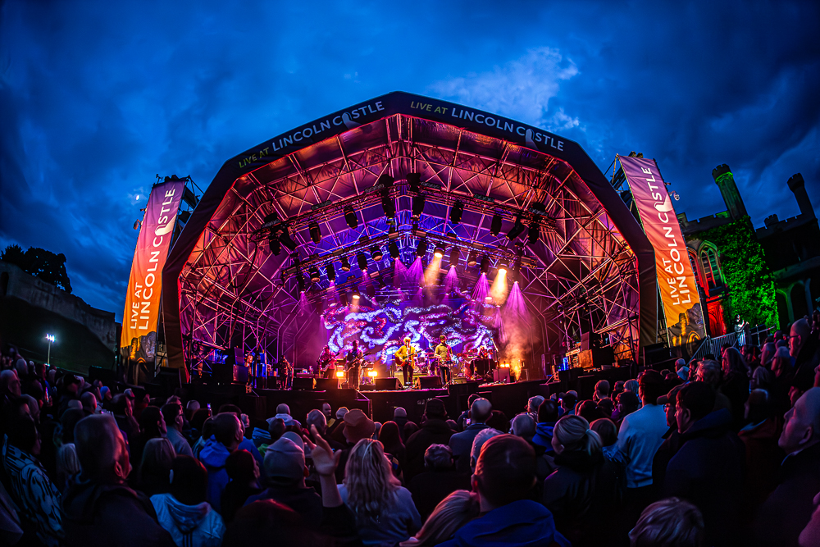

|  |  |
| --- | --- |
| ACCESSIBILITY PACK | |
| EVENT | TK MAXX PRESENTS LIVE AT LINCOLN CASTLE 2025 |
| VENUE | Lincoln Castle, Castle Square, Lincoln LN1 3AA |

## INTRODUCTION

We are excited to welcome you to TK Maxx Presents Live at Lincoln Castle 2025!

**This Accessibility Pack has been designed to ensure that everyone can fully enjoy and participate in our shows.**

Inside, you’ll find detailed information about the venue, including travel options, arrival guidance, a venue description, a site map with distances, and accessible facilities.

We are committed to providing an exceptional experience for all attendees.

[If you require the accessibility pack in an alternative format, please do contact us here](https://cuffeandtaylorhelp.zendesk.com/hc/en-gb/requests/new) and a member of the access team can arrange for you.

## FESTIVAL INFORMATION

## FESTIVAL DATES

|  |  |
| --- | --- |
| Friday 13th June | The Stranglers, Buzzcocks |
| Saturday 14th June | James, The K’s, Tom A Smith |
| Sunday 15th June | Texas, Rianne Downey |
| Thursday 19th June | Rag n Bone Man, Elles Bailey and Kerr Mercer |
| Friday 20th June | Sugababes, DJ Spoony, Freya Ridings |
| Saturday 21st June | UB40 Featuring Ali Campbell, Bitty McLean, Reggae Roast ft Mr Williamz |
| Tuesday 24th June | Sting |
| Wednesday 25th June | Olly Murs, Lemar, Absnt Mind |
| Friday 27th June | The Human League, Thompson Twins’ Tom Bailey and Blancmange |
| Saturday 28th June | Simple Minds, China Crisis |

## FESTIVAL OPENING TIMES

General Admission, Lindum Lounge (VIP) and Accessible gates will open at 6pm.

Entertainment is due to finish at around 10.30pm.

We would suggest arriving early to soak up the atmosphere.

## FESTIVAL MAP

## 

## VENUE DECRIPTION

## DISTANCES

Entrance to accessible viewing platform – approx. 100 metres

Accessible platform to toilets – approx. 30 metres

Accessible platform to nearest bar – approx. 60 metres

Vip area to Accessible platform – approx. 55 metres

## ****WEATHER****

This is an outdoor concert, and we advise attendees to dress appropriately and bring suitable clothing for changing weather conditions. As temperatures may drop in the evening, we recommend bringing a jacket or additional layers for warmth and comfort.

## GROUND CONDITIONS

TK Maxx Presents Live at Lincoln Castle takes place at Lincoln castle, a greenfield site therefore is relatively flat but does have uneven terrain in parts.

The arena features grass, temporary trackway and there is a hard standing path running the length of the site.

The entrance has cobbled pavement due to it being within the castle grounds. [You can see a image of this here for further reference](https://www.google.com/maps/place/Lincoln+Castle/@53.234604,-0.540714,3a,75y,90t/data=!3m8!1e2!3m6!1sAF1QipNBHsozO7xNJC9X72-5a04NQA06sUEAizY3mS8p!2e10!3e12!6shttps:%2F%2Flh5.googleusercontent.com%2Fp%2FAF1QipNBHsozO7xNJC9X72-5a04NQA06sUEAizY3mS8p%3Dw129-h86-k-no!7i1728!8i1152!4m7!3m6!1s0x48785b3cc870552d:0xdee6503590301aeb!8m2!3d53.234604!4d-0.540714!10e5!16zL20vMDRfMWdu?entry=ttu&g_ep=EgoyMDI1MDMxOS4yIKXMDSoASAFQAw%3D%3D).

You can view Lincoln Castle on Google Maps here: [Lincoln Castle](https://maps.app.goo.gl/tZeJWfcyXNimbVtr6)

**Please note:** The terrain may be uneven in parts, and depending on weather conditions, the ground may be muddy or dusty.

## ARRIVAL INFORMATION

The Accessible Lane is via East Gate.

The entrance has cobbled pavement due to it being within the castle grounds. [You can see an image of this here for further reference](https://www.google.com/maps/place/Lincoln+Castle/@53.234604,-0.540714,3a,75y,90t/data=!3m8!1e2!3m6!1sAF1QipNBHsozO7xNJC9X72-5a04NQA06sUEAizY3mS8p!2e10!3e12!6shttps:%2F%2Flh5.googleusercontent.com%2Fp%2FAF1QipNBHsozO7xNJC9X72-5a04NQA06sUEAizY3mS8p%3Dw129-h86-k-no!7i1728!8i1152!4m7!3m6!1s0x48785b3cc870552d:0xdee6503590301aeb!8m2!3d53.234604!4d-0.540714!10e5!16zL20vMDRfMWdu?entry=ttu&g_ep=EgoyMDI1MDMxOS4yIKXMDSoASAFQAw%3D%3D).

Once inside the arena, there is a hard standing path and temporary flooring that leads you to the accessible area.

Upon arrival, you will be required to present your digital ticket, undergo a security bag check, receive an accessibility wristband, and be directed to the accessible viewing platform. Staff will be on hand to assist, and clear signage will be provided

## BOX OFFICE

The Box Office is located at Castle Square, Lincoln LN1 3AA

This is positioned next the general and accessibility entrance.

The opening times are 4pm - 9.30pm on show days.

## WHAT 3 WORDS – KEY ACCESS POINTS

We recommend using the free navigation app[www.what3words.com](http://www.what3words.com/) to help direct from transport to the festival site.

***What is what3words?***  
*“What3words divided the world into 3 metre squares and gave each square a unique combination of three words. It’s the easiest way to find and share exact locations"*

|  |  |
| --- | --- |
| LOCATION (approx) | WHAT 3 WORDS CODE |
| **Nearest Accessible Car Park** | West Gate 1 East: relate.congratulations.scales  The Lawn Car Park: discouraged.sheets.wicked |
| **Pick up and Drop off Point** | smiled.game.costs |
| **Main/Accessible Entrance (East gate, off castle square)** | regime.terms.froze |

## TRAVEL INFORMATION

## CAR PARK

Lincoln Castle is well signposted on brown signs on all major routes into the city.

No accessible parking onsite but the Westgate 1 East Car Park (LN1 3BG) and The Lawn Car Park both have blue badge spaces and are close to the venue

[You can find out more on disabled parking spaces here](https://www.lincoln.gov.uk/directory/2/car-parks/category/57)

## ****PICK UP AND DROP OFF****

Minster Yard will be the Pick-up and Drop off location. You can access this via Pottergate from the South or Priory Gate from the North.

This is 0.2 miles, 350m and approx. 5–10-minute walk to the entrance.

The route is a mixture of hard standing and cobbles but is relatively flat.

## PUBLIC TRANSPORT

## BUS STATION

Lincoln has accessible bus services that can aid you in travelling around the city centre, and up to the Cathedral Quarter. [You can find out more on accessibility on buses here](https://www.visitlincoln.com/plan-your-visit/accessibility-information/#:~:text=Lincoln%20has%20accessible%20bus%20services,and%20space%20for%20a%20wheelchair.)

## TRAIN

Lincoln Central train station is located in the city centre.

From the station it is a 10-minute drive or 20-minute walk.

0.7 miles or 500 metres to Lincoln Castle.

There is a taxi rank outside the station.

[You can find out about accessibility on Lincoln trains here](https://www.nationalrail.co.uk/stations/lincoln/)

## TAXI

Mark’s Passenger Services is a local private hire company with wheelchair accessible vehicles. For more information visit the Marks Passenger Services website or call 01522 793816.  
  
Handsome Cabs also offer wheelchair accessible taxis in Lincoln city centre. 24-hour pre-booking is essential. To book, call 01522 545352.

## FACILITIES

|  |  |
| --- | --- |
|  | **Accessible Toilets**  Accessible toilets are available at all main toilet blocks within the arena.  Additionally, there are accessible toilets within the designated accessible area for accessible ticket holders. These are located inside the building, offering more space and running water compared to standard portable units.  If you need to use the monitored accessible toilets in the accessible area but do not have an accessible ticket, [please contact our accessibility team for further assistance here](https://cuffeandtaylorhelp.zendesk.com/hc/en-gb/requests/new?ticket_form_id=7523357539741)  For VIP ticket holders, a luxury accessible trailer is also available in the VIP area. |
|  | **Accessible viewing platform**  The accessible viewing platform is available for customers with an wheelchair ticket plus their companion. It is raised platform located with prime view of the stage.  Please refer to the map above for the location. |
|  | **Accessible Viewing Area**  The accessible viewing area is a raised space located directly in front of the viewing platform, with seating provided.  It is designated for customers with an ambulant ticket and is intended to accommodate those with specific medical requirements for a more comfortable experience. |
|  | **Charging Facilities**  If you require access to wheelchair charging facilities, please speak to a member of the accessibility team for assistance. |
|  | **Hearing Loops**  There are portable hearing loops available at the box office and main bar (please refer to the map above for exact locations).  Hearing aids need to be switched to the 'T' setting in order to convert the magnetic signal from the loop back into sound. (Please look for the Hearing Loop sign to locate the correct area to be in the frequency radius). |
|  | **BSL Interpreters**  We are pleased to offer a British Sign Language (BSL) interpreter for all concerts.  Deaf/Hard of Hearing ticket holders can access the viewing platform or general admission area, with the BSL interpreter positioned on the left side of the stage (customer view).  The BSL Interpreting Team are listed below:  Charlotte Anderson  Stephanie Mann  [Please note - Subject to change].  [If you have any questions, please contact us here](https://cuffeandtaylorhelp.zendesk.com/hc/en-gb/requests/new) |
|  | **Medication**  Medication in its original packaging, with the prescription label clearly visible, or that is easily recognisable, is allowed without an approval letter.  If the medication is not easily recognisable, [please contact us here](https://cuffeandtaylorhelp.zendesk.com/hc/en-gb/requests/new?ticket_form_id=7523357539741) and we can issue you an approval letter to bring with you on the day of the shows.    Ensure you bring only the necessary amount for the duration of the event, and keep it safe with you at all times.    Medication may be subject to screening at entry points, so please be prepared to provide any necessary documentation, such as a doctor's note, prescription, or the approval letter (printed or digital). |
|  | First Aid and Welfare There are medical and welfare facilities available within the arena. Please ask a member of security to direct you to the facilities if required. |
|  | **Accessible Bar Lanes**  Lowered bar counters, accessible lanes, and large print menus will be available at most bars throughout the festival site for all accessible ticket holders.    If a lowered bar counter is not possible, and when appropriate, a member of staff will be able to come around from the bar to take your order and assist you. |
| A black coffee cup with steam and a fizzy drink cup with a straw and burger outline | Food Traders All food traders will have large print menus available and operate an accessible queue-jump system, with clear signage in place at each stall. Staff will be fully briefed to recognise and assist guests wearing accessible wristbands.  Where a lowered counter is not possible, and when appropriate, a member of staff will be able to come around from the stall to take your order and assist you.  A variety of alternative dietary options will be available.  If you need to bring your own food or non-alcoholic drinks due to a medical condition or your access requirements, [please request this by contacting us here](https://cuffeandtaylorhelp.zendesk.com/hc/en-gb/requests/new) |
| shopping bag" Icon - Download for free – Iconduck | Bags Bags larger than an A4 piece of paper are not permitted. If you require a larger bag due to medical reasons or accessibility requirements,  [please request this by contacting us here](https://cuffeandtaylorhelp.zendesk.com/hc/en-gb/requests/new) |
|  | Sensory Packs Sensory packs are available from the accessible area to borrow free of charge.  Each pack contains a fidget toy, ear plugs, sunglasses, and a sensory distraction.    Backpacks are available on a first-come, first-served basis.    Feel free to bring your own sensory supports if you prefer to have them with you.    Please return the backpacks after the show. All items are sterilized between uses, but sterilizing wipes are included in the bag should you wish to clean them yourself |
|  | **Accessibility Manager, Security and Stewards**  Accessible Events specialise in accessibility for deaf, disabled and/or neurodivergent customers at large scale events. They will oversee the accessible area and be available to assist with any queries you may have on the night.  All security staff and stewards stationed at accessibility points will be fully briefed on procedures to ensure they can provide appropriate support and information to accessibility customers.  **Assistance Dogs**  Assistance dogs are permitted on site. [Please get in touch here if you are bringing a registered assistance dog](https://cuffeandtaylorhelp.zendesk.com/hc/en-gb/requests/new?ticket_form_id=7523357539741). |

**TERMS AND CONDITIONS FOR ACCESSIBLE VIEWING PLATFORM AND AREA.**

* The Accessible Viewing Platform is designated for Wheelchair ticket holders and The Viewing Area is for Ambulant ticket holders.
* Only customers with valid Wheelchair or Ambulant Accessible tickets, and their Essential Companion, may access the Accessible Viewing Platform or Viewing Area, as applicable to their ticket type.
* Access will be controlled via a wristband system.
* The Accessible Viewing Platform and Viewing Area include ramped access, wheelchair-accessible toilets nearby.
* The Accessible Viewing Platform and Viewing Area are not covered; customers should dress appropriately for all weather conditions.
* Smoking, including e-cigarettes and vapes, is not permitted.
* Staff and security reserve the right to ask any customer to leave the Platform and Area if behaving inappropriately.

## CONTACT DETAILS

[You can find further accessibility and event information by clicking here](https://cuffeandtaylorhelp.zendesk.com/hc/en-gb/articles/16111573054109-Frequently-Asked-Questions-Live-at-Lincoln-Castle)

For accessibility enquires please visit the [events help centre here](https://cuffeandtaylorhelp.zendesk.com/hc/en-gb) or  [contact the event organisers  here](https://cuffeandtaylorhelp.zendesk.com/hc/en-gb/requests/new)

If you require a call back, please do leave your phone number with a message on our form and a member of the team will call you back.