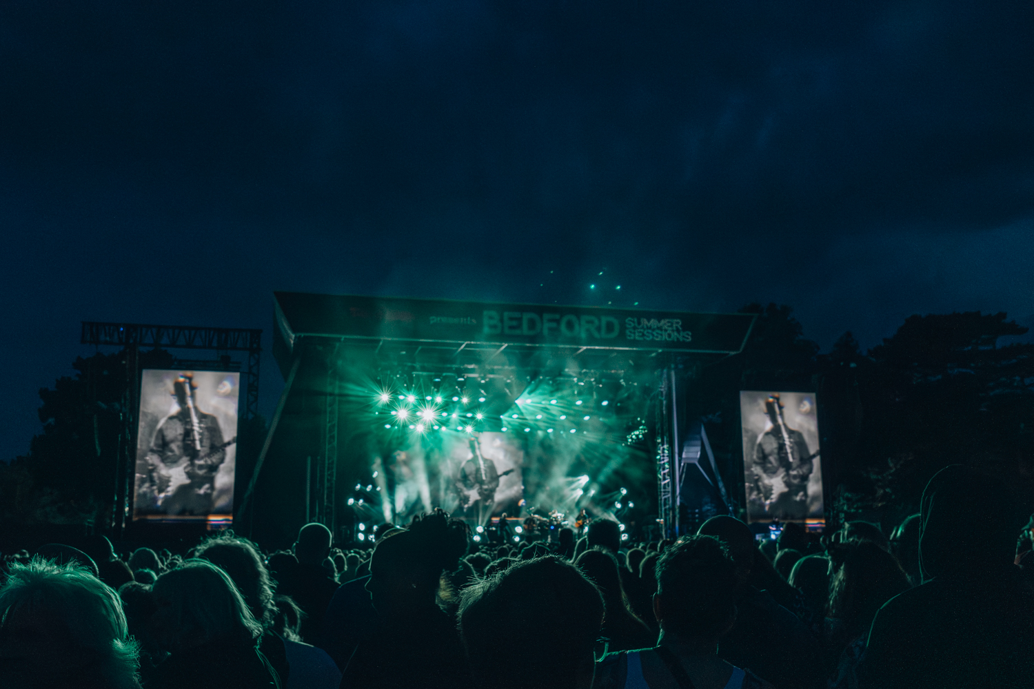

Accessibility Pack

|  |  |
| --- | --- |
| EVENT | TK Maxx Presents Bedford Summer Sessions |
| VENUE | Bedford Park, Park Avenue, MK41 7SS |

## INTRODUCTION

We are excited to welcome you to TK Maxx Presents Bedford Summer Sessions 2025!

**This Accessibility Pack has been designed to ensure that everyone can fully enjoy and participate in our shows.**

Inside, you’ll find detailed information about the venue, including travel options, arrival guidance, a venue description, a site map with distances, and accessible facilities.

[If you require the accessibility pack in an alternative format, please do contact us here and a member of the access team can arrange for you.](https://cuffeandtaylorhelp.zendesk.com/hc/en-gb/requests/new)

## FESTIVAL INFORMATION

## FESTIVAL DATES

|  |  |
| --- | --- |
| Thursday 3rd July | Simple Minds / Alison Moyet / KT Tunstall |
| Saturday 5th July | Rag N Bone Man / Elles Bailey |
| Sunday 6th July | Bedford Proms in the Park |
| Thursday 10th July | Human League +Thomson Twins’Tom Bailey +Blancmange |
| Friday 11th July | Café Mambo Ibiza |
| Saturday 12th July | Supergrass / The Coral / Willie J Healy |
| Sunday 13th July | McFly / Twin Atlantic / Devon |

# FESTIVAL INF

## FESTIVAL OPENING TIMES

General Admission, The Retreat, The Terraced Garden and Accessible gates will open at 5:00 pm.

Apart from Proms in the Park (Sunday 6th July) where gates open at 4:30 pm.

Entertainment is due to finish between 10-10.30pm

We would suggest arriving early to soak up the atmosphere.

## ACCESSIBILITY FESTIVAL MAP

## VENUE DESCRIPTION

## DISTANCES

Accessible car park to Gate A – approx. 550meters

Accessible car park to Gate B – approx. 320meters

Pick up and drop off  to Gate A – approx. 500meters  - this is De Parys Avenue

Gate B to Gate A (over the festival site) – approx. 200meters

Nearest bar from platform  - approx. 50 meters

## ****WEATHER****

This is an outdoor concert, and we advise attendees to dress appropriately and bring suitable clothing for changing weather conditions. As temperatures may drop in the evening, we recommend bringing a jacket or additional layers for warmth and comfort.

## GROUND CONDITIONS

Bedford Summer Sessions takes place on Bedford Park, a greenfield site therefore is relatively flat but does have uneven terrain in parts.

The arena features grass and temporary trackway.

You can view Bedford Park on Google Maps here: [Bedford Park (Summer Sessions)](https://maps.app.goo.gl/rHY76VWjtZdz85Zs6)

**Please note:** The terrain may be uneven in parts, and depending on weather conditions, the ground may be muddy or dusty.

## ARRIVAL INFORMATION

Please note, customers with access tickets may enter the site either via GATE A OR GATE B.

GATE B is closest to the Accessible car park at The Pilgrim Centre. Please be advised once inside the event to reach the AVP and ambulant area you will need to travel across a grass field which may be muddy or dusty depending on the conditions. Gate A is accessible via hard standing from the accessible car park, however this route is a little further.

GATE A is closest to the pick up / drop off area on De Parys Avenue, as well as for anyone arriving from the town centre or on public transport. This route is concrete or hardstanding path and leads directly to the AVP or Ambulant area.

Customers using the Accessible Car Park are welcome to enter the site through Gate A if the concrete path is preferable terrain but please be advised this is a longer route.

There will be signage and stewards available to assist on the day.

**Route from Bedford train station/bus station –** This route consists of pavements and roads through the town, with pedestrian crossings and dropped kerbs along the way.

The train station is approx 1.2 miles from the festival.

The bus station is approx 1 mile from the festival.

Upon arrival, you will be required to present your digital ticket, undergo a security bag check, receive an accessibility wristband, and be directed to the accessible viewing platform. Staff will be on hand to assist, and clear signage will be provided

## BOX OFFICE

The box office is located next to Gate B. As the box office is located on the opposite side of the venue from the accessible entrance, a staff member will be stationed at the accessible entrance to assist. If preferred, please speak to them and they will be happy to help or provide further guidance.

There is a lowered counter available at the box office.

## TRAVEL INFORMATION

## CAR PARKING

Accessible parking is available at The Pilgrim Centre, Brickhill Drive, Bedford - MK41 7PZ.

[You can book tickets here](https://www.universe.com/events/bedford-park-summer-sessions-accessible-car-park-tickets-R2MXWL).

All customers will require a valid, in date, blue badge to use the accessible car park.

Please note cars are not permitted to stay overnight.

## PICK UP / DROP OFF

The pickup and drop off point is at De Parys Avenue which is opposite the main entrance to the park.

This is for all pick up/ drop offs, including taxis, parents, access.

It is approximately 500m from the drop-off point to the entrance.

## ****TAXI FIRMS****

Fastline Taxis have been providing wheelchair-accessible taxi transport for over 22 years. Taxis can accommodate the different types of wheelchairs; standard chairs, sports chairs, battery powered and mobility scooters. Please call up to book in advance.

01234 811811

Ezee Cabs provide a wheelchair accessible taxi service. All taxis are rear loaded or side loaded to accommodate manual and electric wheelchairs and all drivers are experienced in transporting wheelchair users.

01234 273333

## ****PUBLIC TRANSPORT****

## TRAINS

There is step free access at Bedford Train Station, with access to all platforms via a ramp (approx 15 metres long and gradient of up to 1:11). The assistance meeting point is adjacent to the taxi rank at the front of the station.

The train station is approx 1.2 miles from the festival.

[You can find out about accessibility on trains here](https://www.thameslinkrailway.com/travel-information/plan-your-journey/station-information/BDM/Bedford)

## BUSES

The bus station is approx 1 mile from the festival.

[You can find out about accessibility on buses here](https://www.bedford.gov.uk/parking-roads-and-travel/public-transport/bus-timetables-and-maps)

[You can find out more on accessibility on public transport here](https://www.bedford.gov.uk/files/accesstotransport.pdf/download?inline)

## WHAT 3 WORDS – KEY ACCESS POINTS

We recommend using the free navigation app[www.what3words.com](http://www.what3words.com/) to get around the festival.

***What is what3words?***  
*“What3words divided the world into 3 metre squares and gave each square a unique combination of three words. It’s the easiest way to find and share exact locations"*

|  |  |
| --- | --- |
| LOCATION (approx.) | WHAT 3 WORDS CODE |
| Accessible Car Park | sailor.cones.honey |
| Pick up and Drop off Point | plays.candle.echo |
| Box Office | manual.dawn.regime |
| Accessible Viewing Platform/Viewing Area | onions.hike.sage |
| First Aid and Welfare | dishes.powder.shed |

|  |  |
| --- | --- |
|**  | Accessible Toilets Accessible toilets are located throughout the site and can be viewed on the map above. Each set of toilet blocks has an accessible toilet. There are also accessible toilets available in the accessible area. |
|  | **Accessible viewing platform**  The accessible viewing platform is available for customers with a wheelchair accessible ticket.  It is raised platform located with prime view of the stage.  There are accessible toilets and a changing unit located nearby.  This area is for customers who require a wheelchair to make their experience comfortable.  The accessible viewing platform has a limited capacity and is strictly for access customers plus 1 companion only.  **Accessible viewing area**  The ground level viewing area is an area situated directly in front of the viewing platform where chairs are provided.  It is reserved for customers with an ambulant ticket who have a specific medical need requiring a more comfortable environment.  Please note - this area not raised and is located on grass. Therefore, the ground may have uneven terrain in some areas and could be muddy or dusty depending on the weather conditions. |
| Where We Are - Accessoloo | **Accessible Changing Facility**  We have an accessible changing facility available in the accessible area.  Accessoloo are providing us with an accessible changing facility which will be available in the accessible area. The unit includes a toilet with grab rails on either side, an electric hoist, and an adjustable high changing table.  [Please see here for more information.](https://accessoloo.org/about/) |
|  | **Charging Facilities**  There will be charging points for mobility scooters/electric wheelchairs at the viewing platform. |
|  | **Hearing Loops**  There are hearing loops based in the box office and the main bar. Please look for the Hearing Loop sign to locate the correct area to be in the frequency radius. Hearing aids need to be switched to the 'T' setting in order to convert the magnetic signal from the loop back into sound |
|  | **BSL Interpreters**  We are pleased to offer a British Sign Language (BSL) interpreter for all TK Maxx Presents Bedford Summer Sessions 2025 concerts.  Deaf/Hard of Hearing ticket holders can access the general admission area, with the BSL interpreter positioned near the right side of the stage (customer view). If you require assistance getting closer to the BSL interpreter, please ask a member of staff for help.  The BSL Interpreting Team for TK Maxx Presents Bedford Summer Sessions are listed below:  Marie Biswell (all shows)  Annas Bolton (3rd and 10th July)  Jennie Savage (5th, 6th, 11th, 12th July) |
|  | **Medication**  Medication in its original packaging, with the prescription label clearly visible, or that is easily recognisable, is allowed without an approval letter.  If the medication is not easily recognisable, [please contact us here](https://cuffeandtaylorhelp.zendesk.com/hc/en-gb/requests/new?ticket_form_id=7523357539741) and we can issue you an approval letter to bring with you on the day of the shows.  Ensure you bring only the necessary amount for the duration of the event, and keep it safe with you at all times.  Medication may be subject to screening at entry points, so please be prepared to provide any necessary documentation, such as a doctor's note, prescription, or the approval letter (printed or digital). |
|  |  |
| Pint Glass Silhouette Stock Illustrations – 8,838 Pint Glass Silhouette  Stock Illustrations, Vectors & Clipart - Dreamstime | Accessible Bar Lanes Lowered bar counters, accessible lanes, and large print menus will be available at most bars throughout the concert site for all accessible ticket holders.    If a lowered bar counter is not possible, and when appropriate, a member of staff will be able to come around from the bar to take your order and assist you  Accessible ticket holders can also enjoy a dedicated drink service, with bar staff visiting the platform throughout the evening to take orders. |
| A black coffee cup with steam and a fizzy drink cup with a straw and burger outline | Food Traders All food traders will have large print menus available and operate an accessible queue-jump system, with clear signage in place at each stall. Staff will be fully briefed to recognise and assist guests wearing accessible wristbands.  Where a lowered counter is not possible, and when appropriate, a member of staff will be able to come around from the stall to take your order and assist you.  A variety of alternative dietary options will be available.  If you need to bring your own food or non-alcoholic drinks due to a medical condition or your access requirements, [please request this by contacting us here](https://cuffeandtaylorhelp.zendesk.com/hc/en-gb/requests/new) |
|  | Sensory Packs Sensory packs are available from the accessible area to borrow free of charge.  Each pack contains a fidget toy, ear plugs, sunglasses, and a sensory distraction.    Backpacks are available on a first-come, first-served basis.    Feel free to bring your own sensory supports if you prefer to have them with you.    Please return the backpacks after the show. All items are sterilized between uses, but sterilizing wipes are included in the bag should you wish to clean them yourself |
|  | **Accessibility Manager, Security and Stewards**  Accessible Events specialise in accessibility for deaf, disabled and/or neurodivergent customers at large scale events. They will oversee the accessible area and be available to assist with any queries you may have on the night.  All security staff and stewards stationed at accessibility points will be fully briefed on procedures to ensure they can provide appropriate support and information to accessibility customers.  **Assistance Dogs**  Assistance dogs are permitted on site. [Please get in touch here if you are bringing a registered assistance dog](https://cuffeandtaylorhelp.zendesk.com/hc/en-gb/requests/new?ticket_form_id=7523357539741). |

## Terms and Conditions - Accessible Viewing Platform and Ground Level Viewing Area

* The Accessible Viewing Platform is designated for Wheelchair ticket holders.
* The Ground Level Viewing Area is designated for Ambulant ticket holders.
* Only customers with valid Wheelchair or Ambulant Accessible tickets, and their Essential Companion, may access the Accessible Viewing Platform or Ground Level Viewing Area, as applicable to their ticket type.
* Access will be controlled via a wristband system.
* The Accessible Viewing Platform includes ramped access, wheelchair-accessible toilets, and Charging Points.
* The Accessible Viewing Platform and Ground Level Viewing Area are not covered; customers should dress appropriately for all weather conditions.
* Smoking, including e-cigarettes and vapes, is not permitted.
* Staff and security reserve the right to ask any customer to leave the Platform if behaving inappropriately.

## CONTACT DETAILS

[You can find further accessibility and event information by clicking here](https://cuffeandtaylorhelp.zendesk.com/hc/en-gb/articles/16005367556125-Frequently-Asked-Questions-TK-Maxx-presents-Bedford-Summer-Sessions)

For accessibility enquires please visit the [events help centre here](https://cuffeandtaylorhelp.zendesk.com/hc/en-gb) or  [contact the event organisers  here](https://cuffeandtaylorhelp.zendesk.com/hc/en-gb/requests/new)

If you require a call back, please do leave your phone number with a message on our form and a member of the team will call you back.