TK MAXX PRESENTS LIVE AT THE PIECE HALL - ACCESSIBILITY FREQUENTLY ASKED QUESTIONS.

Alternative Formats

The word version of the Accessibility Information is available to download at the bottom of this page.
Click here to download the PDF version of our Accessibility Information.
Should you require this information in an alternative format (Easy read, BSL translated, Audio or anything further), please contact our team, who will be happy to assist.

Accessibility Statement

At TK Maxx Presents Live at The Piece Hall we are committed to providing a welcoming and inclusive environment for all our attendees.
We are extremely proud that TK Maxx Presents Live at The Piece Hall has been awarded the silver level of Attitude is Everything.
The Attitude Is Everything Silver Award recognises the venue's commitment to providing the best possible experience and understanding the potential access requirements of Deaf, disabled, neurodivergent and people with health conditions.
We have a dedicated accessibility team working all year round to assist customers with accessibility requirements.
Please note that our accessible facilities are unable to cater for people with temporary impairments. This is considered to be anything that affects an individual for less than 12 months such as broken bones, healing injuries or pregnant women.

Accessible Ticketing

How do I purchase an accessible ticket?
We want TK Maxx Presents Live at The Piece Hall to be an event accessible for all.
To ensure we have the correct level of facilities we ask customers to purchase the correct type of accessible ticket on Ticketmaster.
The following options are available:
Wheelchair Accessible
- For customers attending in a wheelchair or mobility scooter. This ticket provides access to the accessible viewing platform, which is a raised platform with a clear view of the stage.
Mobility Accessible
- For customers with accessibility requirements who need to have access to a chair to make their experience more comfortable. This ticket also grants access to the accessible viewing platform, which is a raised platform with a clear view of the stage with seating provided.
Deaf/Hard of Hearing
- Provides entry to the general admission area, with the BSL interpreter positioned near the side of stage. Further details will be issued in the accessibility pack closer to the show. If you require accessible viewing platform access or other facilities (e.g. accessible toilets), please get in touch with us. Note: Platform space may be limited.
Essential Companion
Customers purchasing any of the above tickets are entitled to a free companion ticket. You can select this when booking. An approval process follows, where you’ll be asked to submit supporting documentation (see below).
Need a Companion Ticket for General Admission or VIP Areas?
If you're not booking a wheelchair/mobility ticket but need a companion for general admission or VIP areas, please:
- Purchase your ticket via Ticketmaster
- Contact Ticketmaster's Accessibility Team at access@ticketmaster.co.uk with your request and supporting documentation.
- If approved, they’ll issue your companion ticket.

Accessible Documentation

To ensure fans are receiving the correct accommodations and that Free Essential Companion tickets are going to eligible fans, you'll have three weeks to submit proof of eligibility after requesting accessible tickets. Your order may be cancelled if no supporting document is provided.
Below is a list of documents we may accept when considering allocating a complimentary ticket:
- PIP (Personal Independence Payment)
- DLA
- Letter from a medical professional, including a doctor’s note or a letter from an occupational therapist
- Carer's allowance
- A Nimbus Access Card with the +1 symbol. Visit the Access Card page for more information.
- Confirmation in writing from Social Services that the individual is included on their Deaf Register, or a letter or report from an aural specialist confirming that hearing loss has been recorded at 70 - 95 dBHL or worse
- War Pensions Mobility allowance
- Blind or partially sighted registration certificate (BD8 or CVI certificate)
- A personal letter from the GP, community nurse or social worker
- Benefit award letters
- Copy of a blue badge (we would need to see both sides)
Further information is available here
To contact us about purchasing accessibility tickets, or to ask further questions about the process, please email access@ticketmaster.co.uk.

If you have any further questions about the accessible facilities, please contact the event organisers here.

If your request for a companion ticket is not approved, the accessibility team can advise on the procedure.

I don’t need wheelchair or mobility ticket; I just need to access the accessible facilities – what do I do?

If you don’t need platform access but would benefit from facilities such as accessible toilets or entrances, please contact the Accessibility Team by emailing info@thepiecehall.co.uk or call 01422 525200. We’ll be happy to advise.

Arena Accessible Facilities

Accessible Toilets

Accessible toilets are available near the accessible viewing platform and within the main toilet blocks across the venue.
If you require access to the monitored accessible toilets in the accessible area but do not have an accessible ticket. Please contact us for further assistance by emailing info@thepiecehall.co.uk or calling 01422 525200.

Accessible Viewing Platform
The accessible viewing platform is available for customers with an accessible ticket.
It is a raised platform offering a prime view of the stage, and includes:
- Ramped access
- Charging points for mobility scooters and electric wheelchairs
- Accessible toilets located nearby
- Chairs for mobility ticket holders.
- A member of staff on hand to assist
Companions are welcome and will be seated alongside the ticket holder.
Please note: The accessible viewing platform has limited capacity and is reserved for accessibility customers plus essential companion only.
To book this area, please ensure you select the correct ticket type (e.g. wheelchair, mobility) when purchasing.

Accessible Bar, Food and Merchandise Lanes

Lowered counter bars and accessible lanes will be available at most bar areas across the concert site for all accessible ticket holders.
Where a lowered counter isn’t available, a staff member will be happy to assist by coming around the bar to take your order and provide any support you may need.
All food and merchandise stalls will have an accessible queue-jump system in place, clearly signposted at each location. Staff will be fully briefed to recognise and assist guests wearing accessible wristbands.

Site Description
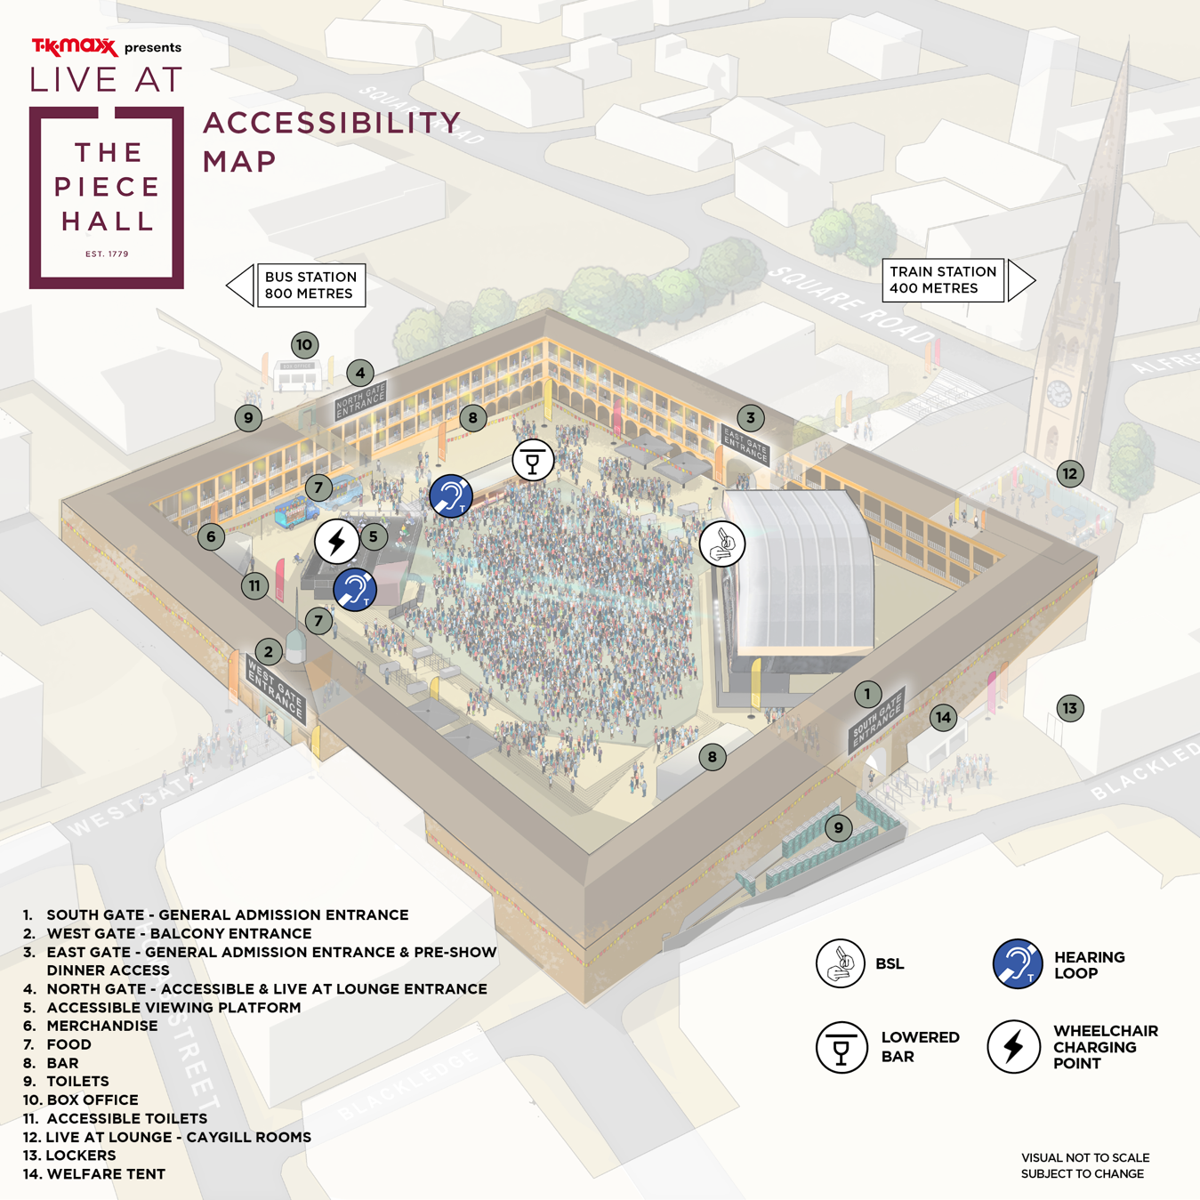
Accessibility Map
Weather
This is an outdoor concert, and we advise attendees to dress appropriately and bring suitable clothing for changing weather conditions. As temperatures may drop in the evening, we recommend bringing a jacket or additional layers for warmth and comfort.

Ground Conditions
The Piece Hall is a Grade I listed Georgian building and historic venue located in the heart of Halifax.

The central courtyard and balconies contain many steps and areas of uneven paving, which are part of the site's heritage so please ensure you take extra care.

Additionally, Halifax’s surrounding streets feature some inclines and cobbles, so visitors are advised to take care when navigating the area. The venue is wheelchair accessible.

You can view The Piece Hall on Google Maps here: The Piece Hall

North Gate - This is the designated accessible entrance. It is level and features hard paving with some cobbled sections.
Live at Lounge customers can also enter via this entrance.
You can view the entrance ground conditions here

East Gate - This is a general admission entrance. It requires stair access to enter the venue.
You can view the entrance of East Gate here

West Gate- This is the entrance for Balcony Ticket holders. This entrance is level and features hard paving with occasional cobbled sections.
You can view the entrance ground conditions here

South Gate – This is a general admission entrance. It is accessed via an inclined path from the street. It features hard paving with occasional cobbled sections.
You can view the entrance of South Gate here

Arrival Process

Our accessible entrance is located on North Gate which is labelled 4 on the map above. There will also be signage available on the day.
Upon arrival, you will be required to present your digital ticket, undergo a security bag check, receive an accessibility wristband, and be directed to the accessible viewing platform. Staff will be on hand to assist, and clear signage will be provided.
You can find out more on digital tickets here

Deaf/Hard of Hearing Facilities

BSL (British Sign Language)
We are pleased to provide British Sign Language (BSL) interpreters at all 2026 shows, with the exception of dance shows.
If you require a BSL interpreter, please purchase a Deaf/Hard of hearing ticket via Ticketmaster.
If you require a BSL interpreter for any of our dance shows, please get in touch to make a request. We kindly ask for at least 60 days’ notice so we can do our best to arrange this service. Please note that while we will make every effort, interpreter provision cannot always be guaranteed.
Deaf/Hard of Hearing ticket holders can access the general admission area [not the viewing platform]. If you need alternative accessible facilities, such as platform access or accessible toilets, please get in touch with us, and we’ll be happy to look into this and discuss further. Please note – the platform may be at capacity.
The BSL interpreter is positioned to the side of the stage.
Full BSL and accessibility details will be included in the Accessibility Pack provided prior to the event.
Hearing Loops
Hearing loops will be available at various locations throughout the event.
Exact locations will be detailed in the Accessibility Pack, which will be sent to all customers prior to the event.
Please look for the Hearing Loop sign to locate the correct area to be in the frequency radius. Hearing aids need to be switched to the 'T' setting in order to convert the magnetic signal from the loop back into sound.

Visually Impaired Facilities

Assistant Dogs

Assistant Dogs are permitted on site. If you are bringing a registered assistant dog, please do contact us here to let us know in advance of arrival.

Audio Description

If you require audio description at any of our shows, please request this by contacting us by emailing info@thepiecehall.co.uk or call 01422 525200
Customers who have requested this service will be contacted by the relevant team for an understanding of which performances they would like covered; this is not guaranteed and is subject to change.
At least 60-days’ notice is advised to ensure we can source and ensure the availability of the audio describers.

Large Print Menus

Large print menus are available at all bars, merchandise stalls, and trader locations throughout the venue.

Sensory Facilities

Strobe Lighting and Special Effects

Smoke machines, strobe lights, fireworks and other effects may be in use at this event. Anyone affected by these should bear this in mind.

If you require further information for a specific performance, please contact the Accessibility Team by emailing info@thepiecehall.co.uk or call 01422 525200.

Sensory Equipment

Sensory equipment is available to borrow free of charge from the welfare area. This includes fidget toys, ear defenders and distraction items.
You're welcome to bring your own sensory supports if you prefer.
If you need further sensory provisions, please contact us by emailing info@thepiecehall.co.uk or calling 01422 525200.

Welfare

There are medical and welfare facilities available. Please ask a member of security to direct you to the facilities if required.
Further information will be released closer to the event.

Accessibility Team, Stewards and Security.

An Accessibility Manager will be on-site, trained in supporting disabled, Deaf, and/or neurodivergent customers. They will oversee the accessible area and be available to assist with any queries you may have on the night.
All security and stewards based at accessibility points will be briefed fully on procedures in order to provide adequate support and information for accessibility customers.

VIP Accessible Facilities
We want everyone to enjoy their VIP experience with us
If you require a companion ticket in the premium area. Please follow the steps below
- Purchase your ticket via Ticketmaster
- Contact Ticketmaster's Accessibility Team at access@ticketmaster.co.uk with your request and supporting documentation.
- If approved, they’ll issue your companion ticket. If your request for a companion is not approved please contact the event organisers who can advise further if required.
Just a note: In some VIP hospitality packages, an additional charge for your companion may apply.
Getting Around – Balcony & Live at Lounge
- Both the Balcony and Live at Lounge have lift access.
- Accessible toilets are on the ground level and available within the Live at Lounge area.
- The Balcony is a raised standing area around the venue. Wheelchairs are welcome, but please be aware views might be partially restricted by the railings.
- The Live at Lounge has some seating, available on a first-come, first-served basis, please note – the stage is not visible from the Live at Lounge seating area.
If you have any other questions about accessibility in our VIP area, please drop us a message at info@thepiecehall.co.uk — our friendly team will be glad to help.
Premium Bar
- An accessible service and clear signage will be available at the premium bar.
- Large print menus are also provided.
BSL interpreter
If you are a VIP ticket holder and require access to the BSL interpreter, please contact us by emailing info@thepiecehall.co.uk or call 01422 525200. Our team will be happy to look into your request and advise you on the best arrangements.
Further Information
For any additional questions about accessibility in the VIP area, please contact the Accessibility Team by contacting us by emailing info@thepiecehall.co.uk or call 01422 525200.

Policies

Bag Policy
Bags, rucksacks, backpacks, and double strapped bags larger than an A4 sheet of paper are not permitted.
If you need to bring a larger bag for medical or accessibility reasons, please contact us by emailing info@thepiecehall.co.uk or call 01422 525200 and we can make arrangements for you.

Food and Drink

There will be various food options available at the concert.
If you need to bring your own food or non-alcoholic drinks due to a medical condition or your access requirements, please contact us by emailing info@thepiecehall.co.uk or calling 01422 525200.and we can make arrangements for you.

Medication
You may bring medication in its original packaging with the prescription label clearly visible, or if it is easily recognisable, without requiring prior approval.
If your medication is not easily recognisable, please contact us so we can issue you an approval letter to bring with you on the day.
- Only bring the necessary amount for the duration of the event.
- Keep your medication safe with you at all times.
- Be prepared for screening at entry points, and have any supporting documents ready, such as a doctor’s note, prescription, or correspondence with the accessibility team.

Temporary Impairments & Pregnancy
Please be aware that our accessible facilities cannot accommodate temporary impairments (e.g. broken bones, healing injuries) or pregnancy. The site involves a significant amount of walking and has limited seating available.
If you have any concerns or specific requirements, please contact us by emailing info@thepiecehall.co.uk or calling 01422 525200 and we can make arrangements for you.

Travel

Car parking
TK Maxx presents Live at The Piece Hall does not have its own car park.
Nearest car park to the accessible entrance:
Woolshops Shopping Centre Car Park (Gaol Ln, Halifax HX1 2XU)
Blue Badge bays available (first-come, first-served)
Approx. 225 metres to the accessible entrance (about a 5-minute walk)
Eureka Car Park
Approx. 270 metres / 0.2 miles from the venue
Find out more here
Additional Blue Badge bays are available throughout Halifax town centre, including:
Alexandra Street, Commercial Street, Corporation Street, Northgate, Old Market, Rawson Street, and Wade Street.
View more details here

Pick-up & Drop-off Point
Available on Charles Street
What3Words location: ///proof.stands.basin
Approx. 115 metres (2-minute walk) to the accessible entrance at North Gate

Taxis
A Star Taxis – 01422 344 111
Book by phone, app, or online here
Ziggy’s Cars – 01422 363 636
Includes a range of vehicles, including wheelchair-accessible options
A1 Ziggy’s Cars website

Train
Halifax Train Station is approx. 320 metres / 0.2 miles (5-minute walk) from The Piece Hall
Find out more about train accessibility here

Bus
Halifax Bus Station is approx. 480 metres / 0.3 miles (7-minute walk) from The Piece Hall
Plan your bus journey and check accessibility information here

Contact Details

You can find out further event and accessibility information by clicking here.
If you have any further questions, please do email info@thepiecehall.co.uk or call 01422 525200

If you require a call back, please do leave your phone number with a message on email and a member of the team will call you back.

