TK MAXX PRESENTS LIVE AT DEPOT - ACCESSIBILITY FREQUENTLY ASKED QUESTIONS.

Accessible Ticketing

How do I purchase an accessible ticket?
We want TK Maxx Presents Depot Live to be an event accessible for all.
To ensure we have the correct level of facilities we ask customers to purchase the correct type of accessible ticket on Ticketmaster.
The following options are available:
Wheelchair Accessible
For customers attending in a wheelchair or mobility scooter. This ticket provides access to the accessible viewing platform, which is a raised platform with a clear view of the stage.
Mobility Accessible
For customers with accessibility requirements who need to have access to a chair or quieter area to make their experience more comfortable. This ticket also grants access to the accessible viewing platform, which is a raised platform with a clear view of the stage with seating provided.
Deaf/Hard of Hearing
Provides entry to the general admission area, with the BSL interpreter positioned near the side of stage (Please see the Deaf/Hard of Hearing tab below for further information)
Further details will be issued in the accessibility pack closer to the show. If you require accessible viewing platform access or other facilities (e.g. accessible toilets, hearing loops), please get in touch with us here - access@depotcardiff.com
Note: Platform space may be limited.
Essential Companion
Customers purchasing any of the above tickets are entitled to free companion ticket. You can select this when booking. An approval process follows, where you’ll be asked to submit supporting documentation (see below).
Need a Companion Ticket for General Admission or Premium Areas?
If you're not booking an accessible ticket but need a companion for general admission or premium areas, please:
- Purchase your ticket via Ticketmaster
- Contact Ticketmaster's Accessibility Team at access@ticketmaster.co.uk with your request and supporting documentation.
- If approved, they’ll issue your companion ticket.

Accessible Documentation

To ensure fans are receiving the correct accommodations and that Free Essential Companion tickets are going to eligible fans, you'll have three weeks to submit proof of eligibility after requesting accessible tickets. Your order may be cancelled if no supporting document is provided.
Below is a list of documents we may accept when considering allocating a complimentary ticket:
- PIP (Personal Independence Payment)
- DLA
- Letter from a medical professional, including a doctor’s note or a letter from an occupation therapist
- Carer's allowance
- A Nimbus Access Card with the +1 symbol. Visit the Access Card page for more information.
- Confirmation in writing from Social Services that the individual is included on their Deaf Register, or a letter or report from an aural specialist confirming that hearing loss has been recorded at 70 - 95 dBHL or worse
- War Pensions Mobility allowance
- Blind or partially sighted registration certificate (BD8 or CVI certificate)
- A personal letter from the GP, community nurse or social worker
- Benefit award letters
- Copy of a blue badge (we would need to see both sides)
Further information is available here
To contact us about purchasing accessibility tickets, or to ask further questions about the process, please email access@ticketmaster.co.uk.

If you have any further questions about the accessible facilities, please contact the event organisers at access@depotcardiff.com

If your request for a companion ticket is not approved, the accessibility team can advise on the procedure.

I don’t need wheelchair or mobility ticket; I just need to access the accessible facilities – what do I do?

If you don’t need platform access but would benefit from facilities such as accessible toilets or entrances, please contact the Accessibility Team at access@depotcardiff.com. We’ll be happy to advise.

Arena Accessible Facilities

Accessible Toilets

Accessible toilets are available near the accessible viewing platform and within the main toilet blocks across the arena.
If you require access to the monitored accessible toilets in the accessible area but do not have an accessible ticket, please contact our accessibility team for further assistance at access@depotcardiff.com.
For Premium ticket holders, a luxury accessible trailer is also available within the Premium area.

Accessible Viewing Platform
The accessible viewing platform is available for customers with an accessible ticket.
It is a raised platform offering a prime view of the stage, and includes:
- Ramped access
- Charging points for mobility scooters and electric wheelchairs
- Accessible toilets located nearby
- Chairs for mobility ticket holders.
- A member of staff on hand to assist
Companions are welcome and will be seated alongside the ticket holder.
Please note: The accessible viewing platform has limited capacity and is reserved for accessibility customers plus essential companion only.
To book this area, please ensure you select the correct ticket type (e.g. wheelchair. mobility) when purchasing.

Accessible Bar, Food and Merchandise Lanes

Lowered counter bars and accessible lanes will be available at most bar areas across the festival site for all accessible ticket holders.
Where a lowered counter isn’t available, a staff member will be happy to assist by coming around the bar to take your order and provide any support you may need.
All food and merchandise stalls will have an accessible queue-jump system in place, clearly signposted at each location. Staff will be fully briefed to recognise and assist guests wearing accessible wristbands.

Accessible Map

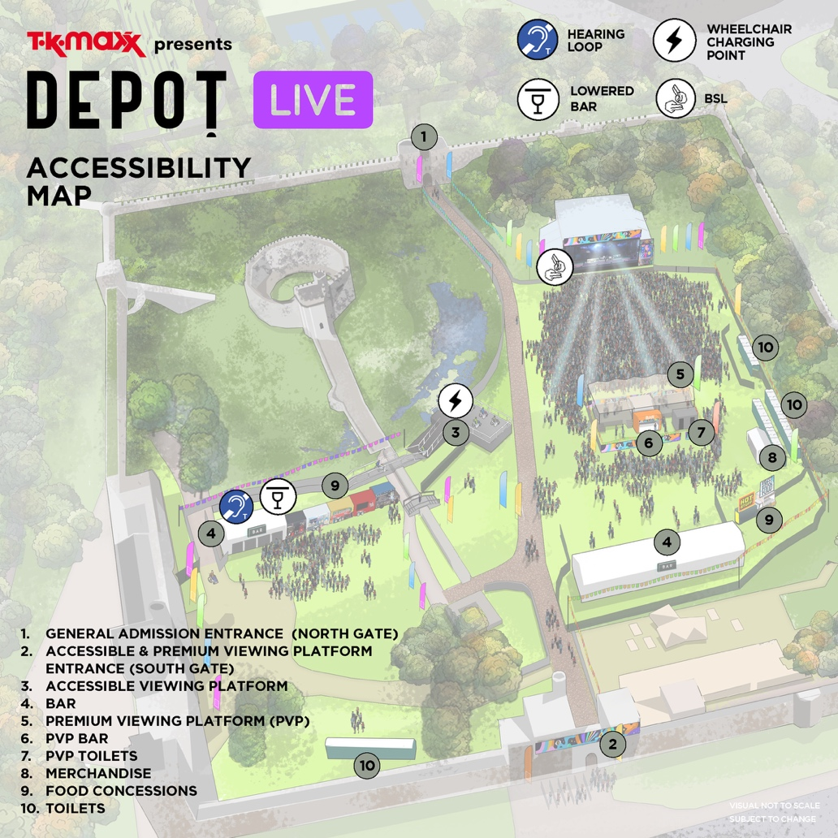

Site Description

Weather
This is an outdoor concert, and we advise attendees to dress appropriately and bring suitable clothing for changing weather conditions. As temperatures may drop in the evening, we recommend bringing a jacket or additional layers for warmth and comfort.

Ground Conditions
TK Maxx Presents Depot Live takes place at Cardiff Castle, a greenfield site therefore is relatively flat but does have uneven terrain in parts.

The arena features grass, temporary trackway, hard standing and just over the drawbridge there is a cobblestone path running the length of the site.

You can view Cardiff Castle on Google Maps here: Cardiff Castle

Please note: Poor weather conditions can impact the terrain, potentially making some areas challenging for wheelchair users or customers with mobility challenges.

Arrival Process

The Accessible entrance is via South Gate. The ground is hard standing paving stones, once inside the path leads left to the ramp to the viewing platform.

Upon arrival, you will be required to present your digital ticket, undergo a security bag check, receive an accessibility wristband, and be directed to the accessible viewing platform. Staff will be on hand to assist, and clear signage will be provided.

You can find out more on digital tickets here

Deaf/Hard of Hearing Facilities

BSL (British Sign Language)
We are pleased to offer British Sign Language (BSL) interpreters at all Show apart from Dance Shows.
If you require a BSL interpreter, please purchase a Deaf/Hard of hearing ticket via Ticketmaster.
If you require a BSL interpreter for any of our dance shows, please get in touch to make a request. We kindly ask for at least 60 days’ notice so we can do our best to arrange this service. Please note that while we will make every effort, interpreter provision cannot always be guaranteed.
Deaf/Hard of Hearing ticket holders can access the general admission area.
The BSL interpreter is positioned to the side of the stage.
Full BSL and accessibility details will be included in the Accessibility Pack provided prior to the event.
Hearing Loops
Hearing loops will be available at various locations throughout the event.
Exact locations will be detailed in the Accessibility Pack, which will be sent to all customers prior to the event.
Please look for the Hearing Loop sign to locate the correct area to be in the frequency radius. Hearing aids need to be switched to the 'T' setting in order to convert the magnetic signal from the loop back into sound

Visually Impaired Facilities

Assistance Dogs

Assistance Dogs are permitted on site. If you are bringing a registered assistant dog, please do contact us here to let us know in advance of arrival.

Audio Description

If you require audio description at any of our shows, please request this by contacting the Accessibility Team at access@depotcardiff.com.
Customers who have requested this service will be contacted by the relevant team for an understanding of which performances they would like covered; this is not guaranteed and is subject to change.
At least 60-days’ notice is advised to ensure we can source and ensure the availability of the audio describers.

Large Print Menus

Large print menus are available at all bars, merchandise stalls, and trader locations throughout the venue.

Sensory Facilities

Strobe Lighting and Special Effects

Smoke machines, strobe lights, fireworks and other effects may be in use at this event. Anyone affected by these should bear this in mind.

If you require further information for a specific performance, please contact the Accessibility Team at access@depotcardiff.com.

Sensory Facilities
Sensory packs are available to borrow free of charge from the accessible area. Each pack includes a fidget toy, earplugs, sunglasses, and a sensory distraction item. Packs are provided on a first-come, first-served basis.
You're welcome to bring your own sensory supports if you prefer.
Please return borrowed packs after the show. All items are sterilised between uses, and sterilising wipes are included in the pack if you'd like to clean them yourself.

Welfare

There are medical and welfare facilities available. Please ask a member of security to direct you to the facilities if required.
Further information will be released closer to the event.

Accessibility Team, Stewards and Security.

An Accessibility Manager will be on-site, trained in supporting disabled, Deaf, and/or neurodivergent customers. They will oversee the accessible area and be available to assist with any queries you may have on the night.
All security and stewards based at accessibility points will be briefed fully on procedures in order to provide adequate support and information for accessibility customers.

Premium Accessible Facilities
Please note:
There are no chairs available in the premium area. Wheelchairs and mobility scooters are permitted in the premium area.
There is ramp access available to the platform.
Companions
If you require a companion ticket in the premium area. Please follow the steps below
- Purchase your ticket via Ticketmaster
- Contact Ticketmaster's Accessibility Team at access@ticketmaster.co.uk with your request and supporting documentation.
- If approved, they’ll issue your companion ticket.
Ground Conditions
The premium area shares the same ground conditions as the main festival arena. The site is a green field—mostly flat, but with some uneven terrain. Ground conditions may be muddy or dusty depending on the weather.
Premium Bar
- A lowered counter, accessible lane, and clear signage will be available at the premium bar.
- Large print menus are also provided.
Luxury Accessible Toilet
There is a luxury accessible trailer available in the premium area too for premium ticket holders.
BSL interpreter
If you are a premium ticket holder and require access to the BSL interpreter, please do contact our team here and they can look into your request and discuss further.
Further Information
For any additional questions about accessibility in the Premium area, please contact the Accessibility Team at access@depotcardiff.com. We are here to help!

Policies

Bag Policy
Bags larger than an A4 sheet of paper are not permitted.
If you need to bring a larger bag for medical or accessibility reasons, please contact us at access@depotcardiff.com and we can make arrangements for you.

Food and Drink

There will be various food options available at the festival.
If you need to bring your own food or non-alcoholic drinks due to a medical condition or your access requirements, please contact us at access@depotcardiff.com and we can make arrangements for you.

Medication
You may bring medication in its original packaging with the prescription label clearly visible, or if it is easily recognisable, without requiring prior approval.
If your medication is not easily recognisable, please contact us so we can issue you an approval letter to bring with you on the day.
- Only bring the necessary amount for the duration of the event.
- Keep your medication safe with you at all times.
- Be prepared for screening at entry points, and have any supporting documents ready, such as a doctor’s note, prescription, or correspondence with the accessibility team.

Temporary Impairments & Pregnancy
Please be aware that our accessible facilities cannot accommodate temporary impairments (e.g. broken bones, healing injuries) or pregnancy. The site involves a significant amount of walking and has limited seating available.
If you have any concerns or specific requirements, please contact the accessibility team at access@depotcardiff.com and we can make arrangements for you.

Travel

Car park
There is currently no on-site parking available.
Public parking is available opposite the venue and on North Road — more details can be found here.
If you require accessible parking, you can use the MiPermit app to locate spaces and display your Blue Badge to park for free.
- Cardiff Council car parks: Free parking for Blue Badge holders.
- Other car parks: May have disabled bays but could require payment.

Bus
Cardiff has many bus stops within a short walking distance.
For stop locations, route maps, and timetables, visit the Cardiff Bus website.
Accessibility information for buses can be found here.
Train
The nearest stations are:
- Cardiff Central – 0.5 miles (approx. 15 minutes’ walk)
- Cardiff Queen Street – 0.8 miles (approx. 18 minutes’ walk)
Find out more about train accessibility here.
Taxi
Capital Cabs Ltd
- Wheelchair-accessible taxis and minibuses available.
- Book via their mobile app (Android & iOS).
- Tel: 029 2077 7777

Contact Details
You can find out further event and accessibility information by clicking here.
If you have any further questions, please do email us by contacting access@depotcardiff.com
If you require a call back, please do leave your phone number with a message on email and a member of the team will call you back.

