TK MAXX PRESENTS SCARBOROUGH OPEN AIR THEATRE ACCESSIBILITY FREQUENTLY ASKED QUESTIONS.

Accessibility Statement
At TK Maxx Presents Scarborough Open Air Theatre, we are committed to providing a welcoming and inclusive environment for all our attendees.
We are extremely proud that TK Maxx Presents Scarborough Open Air Theatre has been awarded the Silver level of Attitude is Everything.
The Attitude Is Everything Silver Award recognises the venue’s commitment to providing the best possible experience and understanding the potential access requirements of Deaf, disabled, neurodivergent, and people with health conditions.
We have a dedicated accessibility team working all year round to assist customers with accessibility requirements.
Please note that our accessible facilities are unable to cater for people with temporary impairments. This is considered to be anything that affects an individual for less than 12 months, such as broken bones, healing injuries, or pregnancy.

Accessible Ticketing

How do I purchase an accessible ticket?

We want TK Maxx Presents Scarborough Open Air Theatre to be an event accessible for all.
To ensure we have the correct level of facilities we ask customers to purchase the correct type of accessible ticket on Ticketmaster.
The following options are available:
Wheelchair Accessible
For customers attending in a wheelchair or mobility scooter. This ticket provides access to the accessible viewing platform, which is a raised platform with a clear view of the stage.
Mobility Accessible
For customers with accessibility requirements who need access to a chair to make their experience more comfortable.
For a fully seated show, an mobility customer will be allocated an end of row seat on the floor seating.
For a standing show, an mobility customer will be allocated a seat on the accessible viewing platform, which is a raised platform with a clear view of the stage with seating provided.
Deaf/Hard of hearing
For Standing Shows – provides entry to the general admission area, with the BSL interpreter positioned near the side of stage. Further details will be issued in the accessibility pack closer to the show.
For Seated Shows – provides entry to seats nearest to the interpreter.
If you require accessible viewing platform access, please get in touch with us (contact details are in the ‘contact us’ tab below). Note: Platform space may be limited.
Essential Companion
Customers purchasing any of the above tickets are entitled to free companion ticket. You can select this when booking. An approval process follows, where you’ll be asked to submit supporting documentation (see below).
Need a Companion Ticket for General Admission Area?
If you're not booking a wheelchair/mobility ticket but need a companion for general admission please:
- Purchase your ticket via Ticketmaster
- Contact Ticketmaster's Accessibility Team at access@ticketmaster.co.uk with your request and supporting documentation.
- If approved, they’ll issue your companion ticket.
Accessible Documentation

To ensure fans are receiving the correct accommodations and that Free Essential Companion tickets are going to eligible fans, you'll have three weeks to submit proof of eligibility after requesting accessible tickets. Your order may be cancelled if no supporting document is provided.
Below is a list of documents we may accept when considering allocating a complimentary ticket:
- PIP (Personal Independence Payment)
- DLA
- Letter from a medical professional, including a doctor’s note or a letter from an occupation therapist
- Carer's allowance
- A Nimbus Access Card with the +1 symbol. Visit the Access Card page for more information.
- Confirmation in writing from Social Services that the individual is included on their Deaf Register, or a letter or report from an aural specialist confirming that hearing loss has been recorded at 70 - 95 dBHL or worse
- War Pensions Mobility allowance
- Blind or partially sighted registration certificate (BD8 or CVI certificate)
- A personal letter from the GP, community nurse or social worker
- Benefit award letters
- Copy of a blue badge (we would need to see both sides)
Further information is available here
To contact us about purchasing accessibility tickets, or to ask further questions about the process, please email access@ticketmaster.co.uk.
If you have further questions on the accessible facilities, please get in touch with us (contact details are in the ‘contact us’ tab below).
If your request for a companion ticket is not approved, the accessibility team can advise on the procedure.

Arena Accessible Facilities

Accessible Toilets

Accessible toilets are available near the accessible viewing platform and within the main toilet blocks across the arena.
You can view the locations via the venue graphical map.

Accessible Viewing Platform

The accessible viewing platform is a raised platform offering a prime view of the stage and includes:
- Ramped access
- Accessible toilets located nearby
- Chairs for ambulant ticket holders.
- A member of staff on hand to assist

Companions are welcome and will be seated alongside the ticket holder.

Please note: The accessible viewing platform has limited capacity and is reserved for accessibility customers plus one essential companion only.

To book this area, please ensure you select the correct ticket type (e.g. Wheelchair Accessible, Mobility Accessible) when purchasing.

Accessible Bar, Food, and Merchandise Lanes

Lowered counter bars and accessible lanes will be available at most bar areas across the venue for all accessible ticket holders.
Where a lowered counter isn’t available, a staff member will be happy to assist by coming around the bar to take your order and provide any support you may need.
All food and merchandise stalls will have an accessible queue-jump system in place, clearly signposted at each location. Staff will be fully briefed to recognise and assist guests wearing accessible wristbands.
A drink service is available on the accessible viewing platform and area. Our bar staff will take your order and deliver drinks directly to your seat. Please note: this service is for cold drinks only.

Site Description

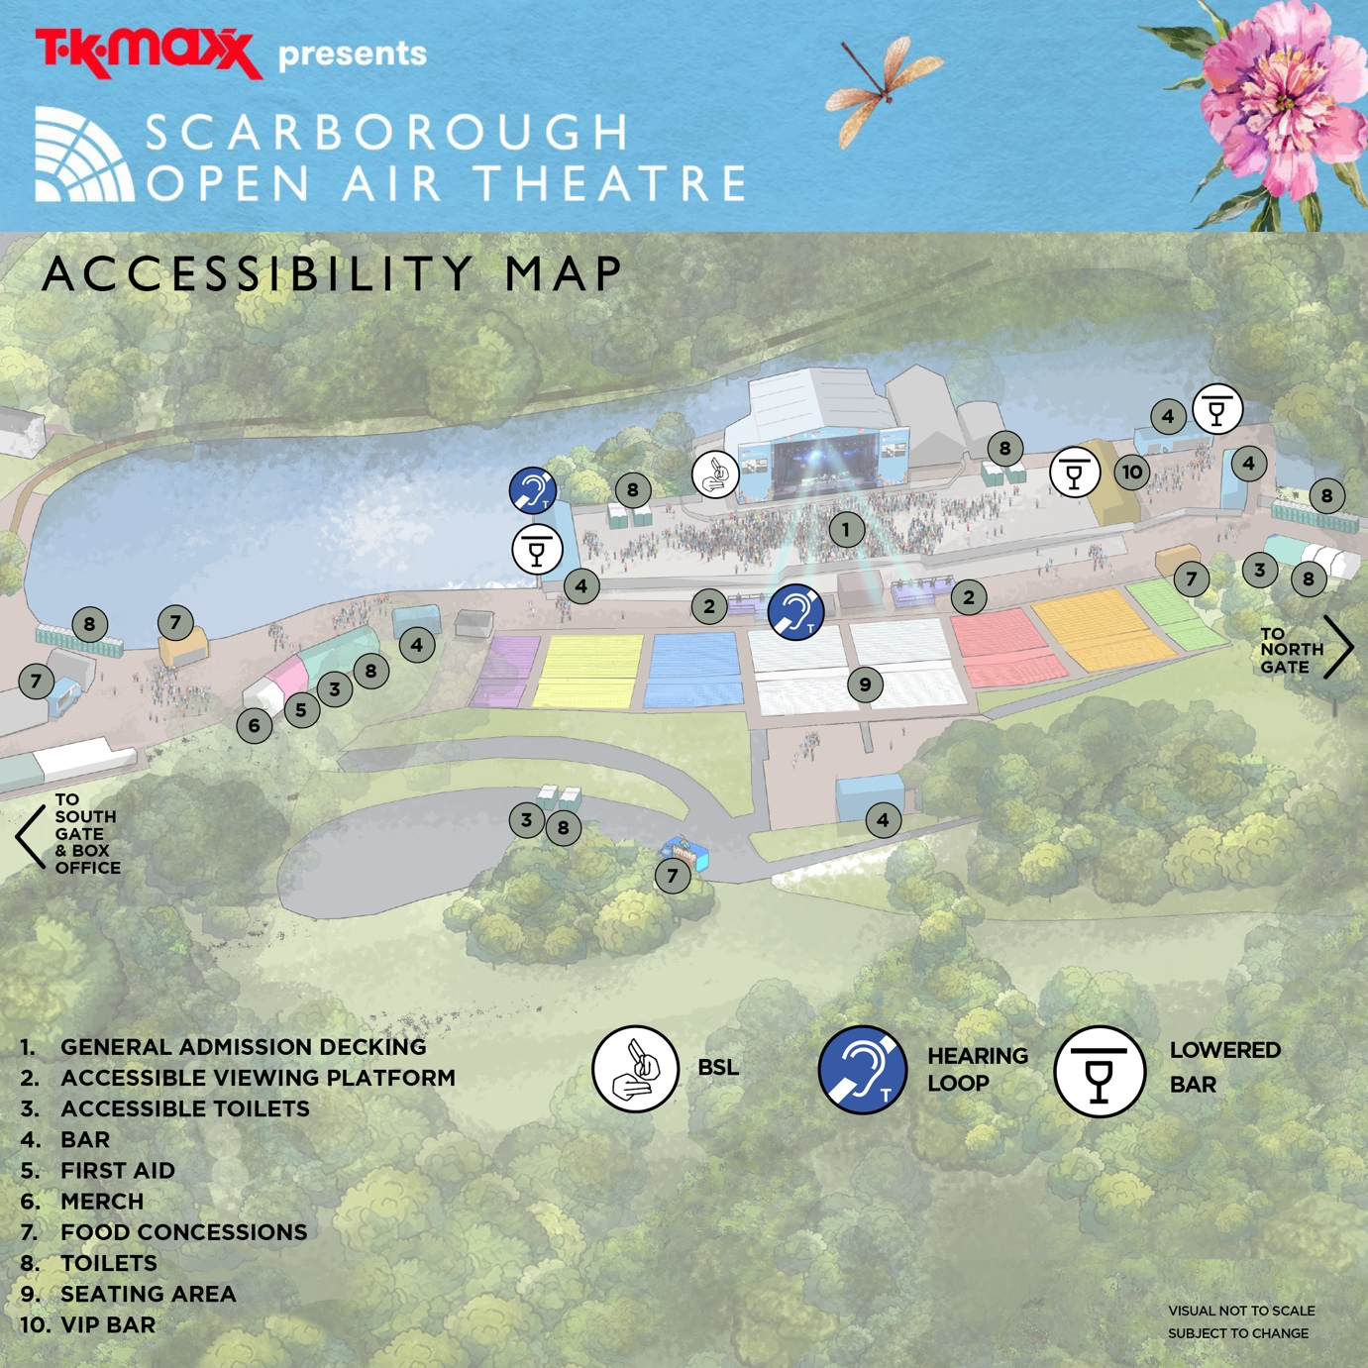
Map

Weather

This is an outdoor concert, and we advise attendees to dress appropriately and bring suitable clothing for changing weather conditions. As temperatures may drop in the evening, we recommend bringing a jacket or additional layers for warmth and comfort.

Ground Conditions
TK Maxx Presents Scarborough Open Air Theatre takes place on hard-standing pavement. The venue has step-free access and is wheelchair accessible throughout.
The path from the entrance to the viewing platform is relatively straight with a slight incline.
You can view Scarborough Open Air Theatre on Google Maps here: Scarborough Open Air Theatre

Arrival Process
The Accessible entrance is via the main entrance at South Gate (just past the box office).
There is an accessible lane located here and there will be signage and stewards available to assist on the day.
Upon arrival, you will be required to present your digital ticket, undergo a security bag check and be directed to the accessible viewing platform. Staff will be on hand to assist, and clear signage will be provided.

You can find out more on digital tickets here

Distances

Box office to Entrance: 65m Approx
Entrance Lanes to Accessible Viewing Platform: 215m Approx
Accessible Viewing Platform to the nearest bar: 45m Approx

Deaf/Hard of Hearing Facilities

BSL (British Sign Language)
We are pleased to offer British Sign Language (BSL) interpreters at all Show apart from Dance Shows.
If you require a BSL interpreter, please purchase a Deaf/Hard of hearing ticket via Ticketmaster.
If you require a BSL interpreter for any of our dance shows, please get in touch to make a request. We kindly ask for at least 60 days’ notice so we can do our best to arrange this service. Please note that while we will make every effort, interpreter provision cannot always be guaranteed.
Deaf/Hard of Hearing ticket holders can access the general admission area.
The BSL interpreter is positioned to the side of the stage.
Full BSL and accessibility details will be included in the Accessibility Pack provided prior to the event.
If you need alternative accessible facilities, such as the viewing platform, please get in touch with us (contact details are in the ‘contact us’ tab below) and we’ll be happy to look into this and discuss further. Please note – the platform may be at capacity.

Full BSL and accessibility details will be included in the Accessibility Pack provided prior to the event.

Hearing Loops
Hearing loops will be available at various locations throughout the event.
Exact locations will be detailed in the Accessibility Pack, which will be sent to all customers prior to the event.
Please look for the Hearing Loop sign to locate the correct area to be in the frequency radius. Hearing aids need to be switched to the 'T' setting in order to convert the magnetic signal from the loop back into sound.

Visually Impaired

Assistance dogs

Assistance Dogs are permitted on site. If you are bringing a registered assistant dog, please get in touch with us (contact details are in the ‘contact us’ tab below). to notify us in advance so that we can ensure your seating is appropriate or arrange suitable alternatives.

Audio Description

If you require audio description at any of our shows, please request this by getting in in touch with us (contact details are in the ‘contact us’ tab below).
Customers who have requested this service will be contacted by the relevant team for an understanding of which performances they would like covered; this is not guaranteed and is subject to change.
At least 60-days’ notice is advised to ensure we can source and ensure the availability of the audio describers.

Large Print Menus

Large print menus are available at all bars, merchandise stalls, and trader locations throughout the venue.

Strobe Lighting and Special Effects

Smoke machines, strobe lights, fireworks and other effects may be in use at this event. Anyone affected by these should bear this in mind.

If you require further information for a specific performance, please contact us here

Welfare

There are medical and welfare facilities available. Please ask a member of security to direct you to the facilities if required.
Further information will be released closer to the event.

Stewards and Security.

All security and stewards based at accessibility points will be briefed fully on procedures in order to provide adequate support and information for accessibility customers.

Policies

Bag Policy
Bags larger than an A4 sheet of paper are not permitted.
If you need to bring a larger bag for medical or accessibility reasons, please get in touch with us (contact details are in the ‘contact us’ tab below).

Food and Drink
There will be various food options available at the concert.
If you need to bring your own food or non-alcoholic drinks due to a medical condition or your accessibility requirements, please request this by contacting us (contact details are in the ‘contact us’ tab below).

Medication
You may bring medication in its original packaging with the prescription label clearly visible, or if it is easily recognisable, without requiring prior approval.
If your medication is not easily recognisable, , please get in touch with us (contact details are in the ‘contact us’ tab below) and we can make arrangements for you.
- Only bring the necessary amount for the duration of the event.
- Keep your medication safe with you at all times.
- Be prepared for screening at entry points, and have any supporting documents ready, such as a doctor’s note, prescription, or correspondence with the accessibility team.

Temporary Impairments & Pregnancy
Please be aware that our accessible facilities cannot accommodate temporary impairments (e.g. broken bones, healing injuries) or pregnancy. The site involves a significant amount of walking and has limited seating available.
If you have any concerns or specific requirements please get in touch with us (contact details are in the ‘contact us’ tab below).

Travel
Car park
There is currently no car parking available on site.
If you are an accessible customer and require a car parking space, we would recommend parking in the Northstead Lower Car Park. You can find out more on the car park by clicking here. This is approximately 50 meters from the entrance to the venue.
If the Northstead Lower Car Park is full, we recommend parking on Royal Albert Drive. The path from this car park to the theatre is flat, which may be more suitable for those in a wheelchair. It is approximately a 10–15 minute walk (0.7 miles) to the Open Air Theatre from Royal Albert Drive. The car parking spaces are on a first-come, first-served basis, therefore it is recommended that you arrive early to ensure a parking space suitable for your requirements.
Pick up and Drop off
There are places to pick up and drop off located at Peasholm Gap, which is just around the corner from Scarborough Open Air Theatre. This is approximately a 5-minute walk (approx. 400 meters).
Bus
All of East Yorkshire buses are low-floor, easy-access buses, which are suitable for wheelchairs. They have ramps at the entrance, allowing wheelchairs to board easily.
You can find out about accessibility on buses here
Train
Scarborough Train Station is located 1.2 miles (5-minute drive and approx. 30-minute walk) to the venue,
Scarborough Station has step free access to all its platforms.
You can find out about accessibility on our trains here
Taxi
Nippys Taxi : Nippy Taxis operate a fleet of wheelchair access and tail lift vehicles. All drivers have completed an appropriate wheelchair safety course.
Number: 01723 377377

Contact us

You can find out further event and accessibility information by clicking here.
For accessibility enquires please visit the events help centre here or please get in touch with us via the details below
Email - OAT.sca@northyorks.gov.uk
Phone: 01723 818111

